The CyberHygiene Project

Beta Test and System Architecture





Donald E. Shannon LLC dba The Contract Coach

Albuquerque NM, 87120

September 29, 2025

## Foreword

This document is a compilation of writings made across the past two years edited and revised where needed to reflect the current project’s direction and progress. The CyberHygeine Project is an ongoing effort, and I fully expect some of the below to need a second or third revision before I finally ‘Get it Right”.

Kudos to my friends and colleagues in the National Contract Management Association (NCMA) and the National Alliance of Apex Accelerators (NAPEX) for their encouragement and moral support these past two plus years.

Much of what I describe or discuss in the following may be more technical than many readers are comfortable with. That is to be expected when diving into a very nuanced and technically detailed discussion – but there are countless tools – including AI – that will parse what is said into more human friendly terms if need be.

Cost is a major factor in doing this project – if cost was not an issue most small businesses would simply write a check and be done with it. That is assuredly one approach. I take a different tack – I look for equally effective solutions that are free but may require a bit of my time or brain power to implement. In many cases this project is the heavy lifting for cyber compliance so follow the breadcrumbs.

When I consider cost, I also consider space and electrical consumption. The products and solutions I offer are all selected with that as a significant factor – because we don’t all have a server rack in our office.

## AI Disclaimer

Portions of this article (especially tabular data) have been obtained from Grok, ChatGPT and Llama LLM AI’s. All AI material was obtained with references to government data sources or published works and the below is therefore copiously documented with the applicable footnotes and references which – in turn – have been vetted by the author. AI content has been Validated by reference checking, edited for readability, and supplemented with commentary by the author to provide added context.

Table of Contents

Foreword 2

AI Disclaimer 2

Chapter 1. Background 6

Chapter 2. Profile of a Typical DIB Very Small Business 7

The VSB Price Tag for the Traditional Cybersecurity Approach 7

What is a Very Small Business? 7

DIB VSB Services or Products 8

VSB Work Environment 9

VSB Staffing 11

Financial Profile of Very Small Businesses 12

VSB Average Annual Revenue 12

VSB Average Annual Operating Costs 12

VSB Average Annual Profit: 13

VSB IT and Cybersecurity Expenses 14

Total Estimated Costs for Cybersecurity Controls 16

Section Summary 17

Chapter 3. Typical DIB VSB Network 19

VSB Network Description and Typology 19

VSB Network Infrastructure 19

Hardware and Operating Systems 20

Typology - Domain vs. Workgroup 22

VSB Security Practices 23

Anti-Malware and Endpoint Management 23

Cloud-Based Services 24

Backup and Recovery 24

Choosing a Network Typology – the Pros and Cons 24

On Premises or Virtual Server 24

Monthly Subscription Fees vs. Long-Term Maintenance 26

Scalability and Flexibility 26

Virtual Device (or Desktop) Interfaces (VDI) 27

Chapter 4. Building a VSB Cyber Compliant Workstation 29

Ditching Microsoft for Open-Source Solutions 29

If not Windows, then what? 30

Selecting the Hardware and Software 32

No Microsoft Windows. 32

Choosing the Right Linux Distribution 33

Building the Beta Systems 33

Beta System Hardware 33

Software 35

End Point Configuration and Hardening 36

The origin of vulnerabilities. 37

Endpoint Hardening 38

Basic Input-Output Systems (BIOS) 38

Operating Systems – Microsoft Windows 38

Hardening Kitty 39

Windows Debloat. 39

Senteon 39

Linux 40

Linux Application Hardening 40

Correcting Vulnerabilities and Misconfigurations. 41

Baseline Maintenance 41

Patching 42

Vulnerability Scanning 43

Chapter 5. Level 1 (Foundational) Network Approach 45

Level 1 Domain Controller 45

Level 1 Components and Services 46

Network Hardening Overview 46

Level 1 Compliance 47

Chapter 6. Level 1 Laboratory Implementation 49

Server 49

Connectivity 51

Firewall / Router 52

Network Switch 52

Chapter 7. Designing a Representative Level 1 Lab Network 53

Network architecture and design considerations 53

Firewall/Router 54

Switches 55

Domain Controller 56

Option 1 – Synology NAS 56

Option 2 – Linux Server 57

The Essential Nature of Third-Party Service Providers 57

Endpoint Management Software/Services 57

BitDefender Gravity Zone 58

Open VPN 59

Cloudflare 59

User Authentication and Multi-Factor Identification 61

pfSense 61

Suricata 62

Summary of Third Party Software and Services 62

Chapter 8. Level 2 Authentication Upgrade 64

Network Hardening Overview 64

How Hardening Enhances Identity Management 64

Updated Gaps and Targeted Actions for Level 2 IA Compliance 65

Implementation Roadmap and Compliance Tips 65

Chapter 9. Rocky Linux Installation and Configuration 67

Installing Rocky Linux 9.6 67

Post Installation 75

Chapter 10. Performing a Client Level 1 (Foundational) Cyber Assessment 78

Chapter 11. Building Out the Level 1 Network: Going Beyond the Solopreneur 79

Chapter 12. Domain Controller (Identity and Access Management 80

Primary Recommendation: 80

Overview 82

Scope and Inventory Assets 82

Compliance with FAR 52.204-21 82

Roles and Responsibilities: 83

Attachments 84

Certification of Compliance 84

1. Background

The CyberHygiene project is a private research effort being conducted by Donald E. Shannon LLC dba The Contract Coach. It began with the creation and publication of an article created for Volume 1 of the Journal of Contract Management published in 2024. In that article, *Technical Ways to Lower Cybersecurity Costs for Small Businesses* I examined the trend of decreasing participation by very small businesses [1](VSB) in the government contracting market and surmised that there appeared to be a correlation between increasingly more stringent (and likely to be implemented) cybersecurity measures and the decline in VSB participation.

In that article I stated the situation could be improved significantly should a commercial entity choose to preconfigure and market a ‘turnkey’ solution at an affordable price point. Such a system would leverage existing tools and technologies – many of them free and open source – to produce a dedicated secure environment for the small business. Much of the effort was seen as being accomplished by automated tools to properly configure the hardware and produce the necessary policies and procedures from standardized templates. This approach was deemed possible by virtue of a very narrowly defined segment of users with many common attributes, environments, and needs.

The project has been briefed to the national leadership of the National Apex Accelerator Alliance (NAPEX) and the National Contract Management Association (NCMA). At present the effort is focused on Solopreneurs (one person companies) with an interest in contracting with the Federal Government who need to meet the security requirements for Federal Contract Information (FCI).

Ultimately this core effort will be enhanced and expanded to cover VSBs at the FCI level and ultimately to prepare the same entities for Controlled Unclassified Information (CUI) and CMMC requirements.

1. Profile of a Typical DIB Very Small Business

A recent survey I conducted[2] of Defense Industrial Base (DIB) participants showed that the majority of the contractors (about 78 percent) were very small businesses (VSBs) with 10-20 employees. I also determined that VSB participation in the DIB was declining, new entrants to the market were declining, and a potential factor in that decline was a cost barrier in the form of cybersecurity compliance requirements.

The Defense Federal Acquisition Regulations (DFARS) clause 252.204-7020 requires a summary score for a self-conducted ‘Basic Assessment’ to be posted in the Supplier Performance Risk System (SPRS) to be eligible to propose for-let alone be awarded- a government contract.

## The VSB Price Tag for the Traditional Cybersecurity Approach

I conducted a study of the estimated cybersecurity costs for new entrants to the DIB, in fall 2022 using AI and other related research tools. This paper provides an overview of the typical DIB small business profile for companies with less than 20 employees, including demographics, revenue, employee size, and cybersecurity maturity based on that study. My conclusion was meeting the basic assessment requirement using the existing methods would cost somewhere around $38,000 to $50,000 and constituted a major barrier to VSB participation in the DIB. I also surmised:

“The first step is defining a narrow use case for the Cyberhygiene Project through assumptions and requirements definitions. This will lead to creating a consensus SB office and network configuration that can comply with the government’s cybersecurity requirements.”

This paper addresses the above requirement by identifying the target audience (i.e., VSBs) and then proposing a system architecture and other products needed to prepare them for the DFARS basic cybersecurity assessment on a budget of +/- $5,000 vs a more traditional approach costing $35,000 to $50,000.

## What is a Very Small Business?

The issue concerning cybersecurity cost is driven by not only the overall cost, but also by the fact that the costs are largely one-time expense that must be met before the VSB is eligible for their first contract. The nature of the business (small size, modest contract value, modest profit margins) means the initial expenses will likely need to be considered a capital investment as opposed to a recoverable contract expense. Consequently, lowering the cost of entry to the DIB is likely to have a significant impact on VSB participation.

The target audience for the Cyberhygiene project is provided in the below:

Table Summary of Very Small Business Characteristics

|  |  |
| --- | --- |
| Category | Typical Small Business Profile |
| Number of Employees | 0 -10 employees typical. maximum of 15 |
| Annual Net Revenue | Less than $1.5 million |
| Industry | Various industries supporting the DoD and government agencies |
| Ownership | Primarily Sole Proprietorship or Partnership [3], [4] |
| Legal Structure | Limited Liability Corporation or S-Corporation [5] |
| IT Infrastructure | Typically, local area network using Wi-Fi connections. Progressing from an ad-hoc workgroup to a domain-controlled network as size increases. Predominately cloud-based management or third-party managed by MSP. Some on-premises servers especially where concerns for security and confidentiality ate paramount. |
| OT Infrastructure | Little OT infrastructure evident in knowledge-based entities (engineering, R&D, and consulting) although some OT assets may exist in engineering (prototyping) and manufacturing. |

### DIB VSB Services or Products

Many DIB contractors provide commercial off-the-shelf products that are not covered by the cybersecurity requirements of the FAR (52.204-21) or DFARS (252.204-7012) and are consequently not of interest. The DIB Contractors of primary interest[6], are:

1. Engineering and technical services: These businesses may provide a range of engineering and technical services to support military and defense programs, such as systems integration, testing, and evaluation.

2. Software development: Many small DIB businesses specialize in software development for military applications, including data analytics tools, cybersecurity solutions, and other advanced technology systems.

3. Research and development: These businesses may engage in research and development of new technologies and innovations to meet the needs of the defense sector, such as advanced materials, sensors, or communication systems. [7], [8]

4. Consulting services: Some small DIB businesses may offer consulting services related to defense industry best practices, regulatory compliance, or other specialized areas of expertise.

The above data was cross-checked and verified with the results of a recent DAU study[9] of small business awards in the defense industry. The following is a list of the top NAICS (North American Industry Classification System) codes for contracts awarded to small businesses noted by DAU and a strong correlation between the two studies is noted.

Table Most Common DIB Small Business NAICS

|  |  |  |  |
| --- | --- | --- | --- |
| NAICS Code | Description | Number of Small Business Contracts (2022-2023) | Total Award Value (2022-2023) |
| 541330 | Engineering Services | 1,250+ | $2.1 billion |
| 541715 | R&D in Physical, Engineering, and Life Sciences | 900+ | $1.5 billion |
| 561210 | Facilities Support Services | 700+ $ | 1.2 billion |
| 541512 | Computer Systems Design Services | 650+ | $1.1 billion |
| 236220 | Commercial & Institutional Building Construction | 600+ | $950 million |
| 541519 | Other Computer Related Services | 550+ | $850 million |
| 541611 | Admin. & General Management Consulting | 500+ | $800 million |

NAICS codes in the preceding study represent areas where small businesses play a prominent role as prime or subcontractors in supporting defense operations. Engineering services, R&D, and systems design are highly sought after due to their impact on innovation and national security priorities.

Another factor to consider is the amount of capital investment required may act as a barrier for VSBs to enter specific industries. Studies indicate that capital investment requirements generally correlate with industry type, as represented by NAICS codes, and this impacts both entry barriers and success rates. Industries with high capital requirements (e.g., manufacturing, construction) exhibit slower growth and have fewer VSBs due to the significant upfront costs, whereas industries like professional services with lower capital requirements see higher levels of entry and growth potential for small businesses (Bartik, 2018; SBA, 2021)[10].

### VSB Work Environment

The dominant VSB environment appears to be highly leveraged off the work-at-home concept that gained prominence during COVID-19 has led to a substantial transformation in work conditions. The work environment typically emphasizes flexibility, and cost-effectiveness.

Many VSBs operate from home offices, co-working spaces, or small rented spaces, where physical settings support a collaborative and often informal work culture. This environment allows VSBs to maintain low overhead costs while fostering close relationships among team members. Given their size, many VSBs also prioritize flexible work arrangements, like remote work and adaptable schedules, which are attractive for employee retention and can help manage work-life balance effectively. This is particularly common in professional services, construction, and retail sectors, which constitute a large share of VSBs in the U.S.

Studies highlight that VSBs’ productivity and longevity can benefit significantly from an environment where employees feel supported and have opportunities to contribute meaningfully, rather than purely hierarchical structures more common in larger businesses (McKinsey, 2024; Rocket Lawyer, 2023) [11], [12], [13]

While most sole proprietors work from a home office, the prevailing environment for small businesses with employees is a hybrid combining the following elements in various combinations:

1. Home office: Numerous professional services and knowledge-intensive firms function from home offices, with the owner/CEO and other personnel working remotely using Virtual Private Networks (VPN) or Virtual Device Interfaces (VDI) to connect to cloud services or clients. This can reduce overhead expenses and offers an economical environment. flexibility. Home offices are dominant with sole proprietorship VSBs.

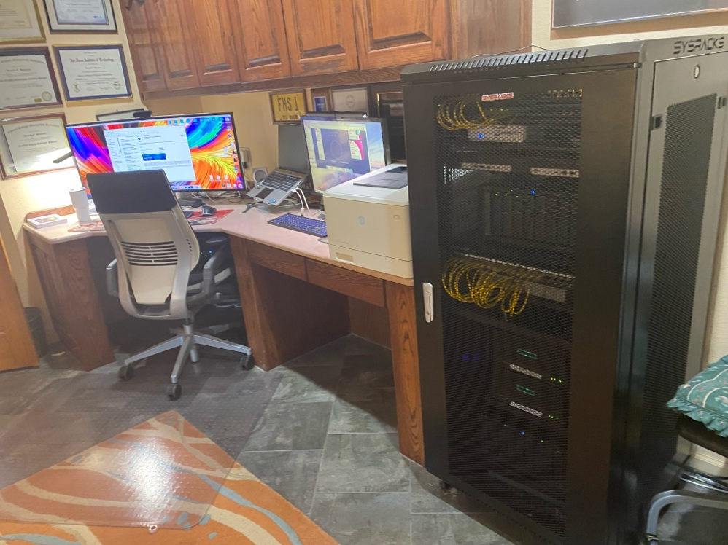

Figure Home Office/Lab used by the Author

1. Compact office space: Numerous DIB enterprises may lease (or share) a compact office space situated in office parks or facilities near government installations to create a professional setting for meetings and customer engagements. Often these facilities are part of an ‘accelerator’ environment with several STEM related VSBs clustered together. Such an arrangement is often conducive to synergy and collaborative efforts.
2. Virtual team: With advancements in communication technology, some small DIB enterprises have implemented virtual team frameworks, wherein employees operate remotely from various places and primarily interact through video conferencing, instant messaging, and other digital tools. This technique is often used when team members are geographically dispersed and facilitates international participation.
3. Flexible work arrangements: To meet the requirements of its staff and clients, small DIB enterprises may provide flexible work options like as telecommuting, part-time schedules, or reduced workweeks. This is a common work/life balancing tactic to attract or retain highly sought-after talent.
4. Facilities offered by the customer. To meet customer or governmental security mandates, some small enterprises engaged in classified or sensitive projects utilize secure premises provided by the prime contractor or government for conducting sensitive or classified work.
5. Virtual offices created in apps such as MS Teams, Zoom or other conferencing apps that include instant messaging and collaboration via impromptu meetings.

### VSB Staffing

Small DIB entities in this study are sparely staffed with a very heavy representation by revenue earning staff and a relatively small administrative or overhead team. According to Forbes[14] sole proprietors dominate the small business landscape and “The professional and business services industry now leads in job openings, a shift from the previous trend where education and health services were more in demand. This change signals a strong need for skilled workers in areas such as management, administration and consulting.”

The numbers in the DIB are different with approximately 50% (4,928 of 9,336) having 0 – 5 employees (referred to in my article as ‘nano’ small businesses)

Directionally, these data point to many sole proprietors

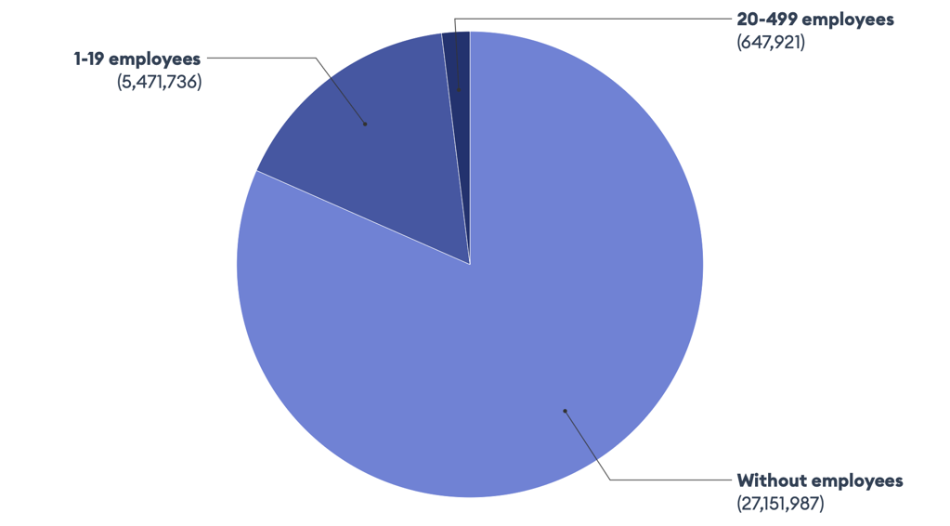

Figure Distribution of Small businesses by number of employees.[15]

Typical staffing for VSBs with employees includes:

1. Owner/CEO: The owner/CEO is typically actively involved in VSB management, responsible for managing the day-to-day operations of the business, securing government contracts, and overseeing the development of new technologies and products.
2. Engineers and Technical Staff: These employees may have backgrounds in engineering, computer science, or other relevant fields and are responsible for developing and testing new technologies and products.
3. Business Development: These functions, i.e., marketing materials, writing proposals, and identifying potential government contract opportunities are frequently performed by the owner/CEO and Engineers with some specialized assistance such as costs or pricing provided by CPA’s or outside consultants.
4. Administrative staff: This may include an office manager, accountant, and other support personnel who handle tasks such as bookkeeping, payroll, and human resources management. [16]

Figure Notional Organization Chart for Very Small Business

## Financial Profile of Very Small Businesses

The average annual revenue, costs, and profit for a small defense industrial base business can vary widely depending on factors such as the specific products or services offered, the size of the company, and the geographic area. However, here are some general estimates based on industry studies and reports:

### VSB Average Annual Revenue

According to a report by Deloitte,[17] the average annual revenue for small and medium-sized defense companies is around $10 million to $50 million (Deloitte, 2019). A second report by the National Defense Industrial Association (NDIA) found that the average annual revenue for small defense companies was around $25 million (NDIA, 2020). However, these numbers are averages for all small businesses (including some with 250 or more employees) and the revenue for very small businesses (VSBs) is significantly less as shown in Table 2.

### VSB Average Annual Operating Costs

For small businesses working with the government, the Defense Contract Audit Agency (DCAA) focuses heavily on accurately categorizing and reporting costs. The DCAA's guidance on cost accounting includes several essential categories that small businesses should track, especially when operating under government contracts. Here’s a general breakdown of cost categories suitable for businesses with 0-5, 6-10, and 10-20 employees:

Table Estimated Business Costs (exclusive of IT and Cybersecurity) for Very Small Businesses [18], [19].[20]

|  |  |  |  |  |  |
| --- | --- | --- | --- | --- | --- |
| Business Size (Employees) | Components of Direct Costs | Direct Costs (Annual) | Indirect Cost (Overhead) | Indirect Cost (G&A) | Indirect Costs  (Annual) |
| 0-5 | Labor, materials, and any direct contract-specific travel | $20,000 - $100,000 | Overheads such as small-scale utilities, facility costs (if applicable), and minor indirect labor | Executive salaries, accounting, small marketing expenses, and office supplies | $10,000 - $50,000 (utilities, small rent, etc. |
| 6-10 | Similar to above, including specialized materials for specific projects | $100,000-$500,000 | Higher facility overheads, fringe benefits, increased utilities, material handling | Increased G&A due to additional administrative support or expanded marketing efforts | $50,000 - $200,000 (expanded facility & benefits) |
| 10-20 | Expanded to include direct labor for specific project teams, and more travel expenses per project | $500,000 - $1,000,000 | Larger pools for employee benefits, more substantial facility overheads, and depreciation | Additional G&A for compliance, higher-level staffing, and increased executive support and legal or financial services | $200,000 - $500,000 (benefits, facility overhead) |

Note that while cybersecurity costs are an important factor in business profitability and can serve as a challenge to entering the DIB, they are technically one-time costs related to compliance with the applicable standard(s) required by the industry – be that financial, health care, or government contracts. Those costs are not included in the above analysis. However, IT costs such as annual service and support fees, Managed Service Providers, etc. are included. Tri-annual cybersecurity recertification assessment is a potential outlier in the above as it is likely to add as much as $5,000 to $15,000 in General and Administrative costs annually to the budget.

### VSB Average Annual Profit:

A GAO study found that the average annual profit for small defense companies was on average 5% to 10% of their total revenue[21]. A report by the consulting firm McKinsey & Company found that the average annual profit margin for small defense companies was around 7% to 10%. [22], [23], [24] ,[25]

Table Average annual revenue and profit for VSBs

|  |  |  |  |  |
| --- | --- | --- | --- | --- |
| Employee Count | Average Annual Revenue | Average Annual Cost | Estimated Profit | Average Profit Margin (%) |
| 0–5 Employees | $47,794 - $400,000 | $43,000 - $370,000 | $4,794 – $30,000 | 7% - 10% |
| 6–10 Employees | $500,000 - $1,000,000 | $450,000 - $900,000 | $50,000 - $100,000 | 7% - 10% |
| 11–20 Employees | $1,000,000 - $1,800,000 | $900,000 - $1,590,000 | $100,000 – $210,000 | 7% - 10% |

These data are echoed by a study in Forbes Advisor where the range of salaries was between 32,000 and $147,000 with a mean of $69,000/year.

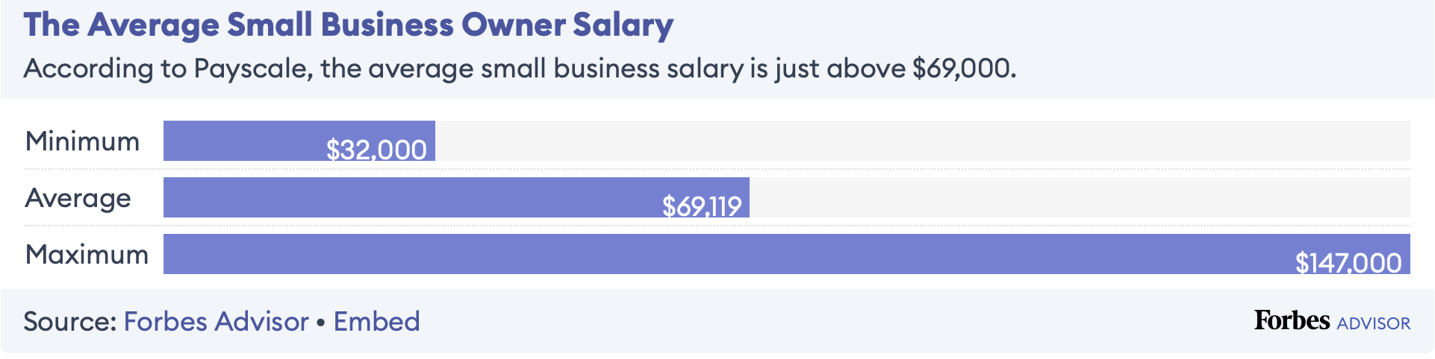

Figure Average small business owner salary **[26]**

These estimates are based on industry-wide averages and may not reflect the specific financial performance of any individual small DIB business. Additionally, the profit margins for these companies can vary widely depending on factors such as the type of products or services offered, the size of the company, and the target markets served.

According to a report by the Small Business Administration (SBA) and as reported in my journal article[27], most (approximately 72 – 78 percent) of small DIB with employees only have a few, typically less than 20. These companies have a lean organizational structure and may outsource specialized functions or services such as IT, accounting, or legal to supplement in-house staff.

Larger DIB companies may have employee numbers ranging from 50 to several hundred employees with more complex organizational structures and may offer a wider range of products and/or services to their customers.

Revenue (and profit) are a somewhat linear function and correlate well with the number of employees – especially in knowledge-based businesses. Consequently, the SBA reported average annual revenue of $10 million for small DIB businesses is likely based on an unweighted average including companies ranging from 20 to 500 employees (or larger). The data is somewhat skewed by the award size for businesses close to the size limit for the NAICS code.

## VSB IT and Cybersecurity Expenses

IT and cybersecurity spending depend on industry, data sensitivity, and compliance requirements, especially for government contractors who face strict cybersecurity mandates. Hence, these costs are tracked separately.

For small businesses, annual IT and cybersecurity spending are estimated to represent about 10-12% of their overall IT budget[28]. However, the IT expense per person varies widely depending not only on employee count but also the nature of the industry (Financial, Legal, Retail, Health Services, or Government Contracting) as each of these industries has specific security requirement they must meet.

Since larger businesses have more people to spread the cost over, their per person costs tend to flatten out once a certain size is attained. Those at the low end of the size spectrum will have significantly higher per-person costs. On average, a 10 – 20 person very small businesses may spend around $4,500 ($300 per user) per month on IT including equipment purchase or lease, internet access, help desk services, etc. This figure assumes the business can find a provider willing to take on a client with so few employees which is a significant issue for many VSBs

To the IT costs we now add add cybersecurity, SaaS, or other support costs that may range from $300 to $500 monthly, or approximately $3,600 to $6,000 annually for a very small business. This includes essential services like end-point management, network security, incident response, employee refresher training, and vulnerability scanning & monitoring. Total IT and cybersecurity could approach 50K for a 10-person office.

For government contractors, the costs can be higher due to compliance needs with frameworks like NIST SP 800-171 and DFARS regulations. Cybersecurity costs may represent 15-20% of IT spending for these businesses, reflecting the added requirements for compliance with federal standards and cyber risk mitigation efforts. Small businesses could expect annual cybersecurity expenses between $7,200 and $12,000[29] when including advanced security measures, FedRamp approved storage or email, and regular compliance assessments.

Table : IT and Cybersecurity Costs for VSBs [30],[31],[32]

|  |  |  |  |
| --- | --- | --- | --- |
| Business Size | IT Managed Services (Monthly) | Cybersecurity (Monthly) | Cybersecurity (Annually) |
| 0–5 Employee | $1,500 | $300–$400 | $3,600–$4,800 |
| 6–10 Employee | $3,000 | $500–$600 | $6,000–$7,20 |
| 10–20 Employee | $5,000 | $750–$1,000 | $9,000–$12,000 |

Note: These estimates are generalized in nature. Exact costs may vary based on the specific industry and risk level of the business. Compliance-heavy sectors like financial, healthcare, or government contracting will generally have higher cybersecurity expenses due to stricter regulatory requirements. A more detailed analysis of the costs is included in Level 1 (Foundational) Approach below.

Investments in cybersecurity are often categorized into these areas:

* Hardware (servers, desktops, and laptops)
* Software (productivity, security, specialized tools)
* Network infrastructure (routers, switches, firewalls)
* IT or consultant support

The estimated annual cybersecurity costs for very small DIB businesses should also include an allowance for:

* Cybersecurity software (antivirus, intrusion detection)
* Cybersecurity services (incident response, penetration testing)
* Employee training and awareness programs
* An allowance for assessment services such as CMMC (triennial) or when the system is modified

The total cost of NIST SP 800-171 compliance for low and moderate threats VSBs is the subject of my ongoing study. In my JCM article[33] I estimated these costs saying: “The total cost based on this analysis for a company of 20 or fewer employees is in the range of $37,000 to $50,000 with a midpoint of about $44,000 excluding annual costs for other IT services such as Office 365, GCC, etc. This figure does not include labor costs for the business to support or manage the (compliance) effort”

Recently, the Federal Register published a proposed rule **Federal Acquisition Regulation: Controlled Unclassified Information[34]** pegged the estimated cost at: “The total estimated labor cost for a small business in the initial year is approximately $148,200 (average of 1,560 hours * $95), with a recurring annual labor cost of approximately $98,800 (1,040 hours * $95). … Businesses may also need to install software and/or hardware to implement NIST SP 800-171 Revision 2. …. The Government estimates that a small business, on average, may spend $27,500 on hardware and software during initial implementation and $5,000 annually thereafter to maintain compliance.”

The above cost estimates only address NIST SP 800-171 Moderate compliance (i.e., DFARS 52.204-7012) **without any third-party assessment**. Adding a third-party assessment was seen as adding another $15,000 – $50,000 or more to the initial costs. Also, the assessment is a recurring requirement so a portion of that cost would need to be set-aside each year to pay for the tri-annual recertification under CMMC.

### Total Estimated Costs for Cybersecurity Controls

Cybersecurity costs include the software, hardware, and services needed to provide either a level of cyber hygiene (e.g., FIPS 199 and 200 as ‘Low Impact’) primarily protecting Federal Contract Information (FCI) or alternately ‘adequate security’ (Typically associated with Moderate or High Impact) protecting Controlled Unclassified Information.

The impact of these costs is best expressed by the National Defense Industry Association:

“… Therefore, understanding the costs to contractors to safeguard information is an essential element to ensure that companies, especially small businesses and start-up companies, are not regulated out of their ability to support the Department and its missions.”[35]

Implementation is typically performed in a staged manner with Low Impact typically accomplished first, followed by Moderate Impact. High impact is viewed by the author as extremely rare (but not impossible) for VSBs.

The below chart summarizes hypothetical implementation costs:

Table Estimated Cybersecurity Implementation Costs for a notional 10 - 20-person company

|  |  |
| --- | --- |
| Category | Estimated Cost Range  (10 to 20 employees |
| Initial Hardware, Equipment, and start-up (Greenfield) | $5,000 |
| Gap Analysis and Remediation | $5,000 to $15,000 [36] |
| Policy and Procedures Manual | $ 5,000 to $12,000 |
| Cybersecurity training for employees | $ 3,000 to $5,000 [37] |
| Incident response planning and training | $3,000 to $7,000 |
| Penetration testing and vulnerability assessment | $7,000 to $15,000 |
| Total (self-assessment only) | **$16,000 to $39,000** |
| Total with Third-Party assessment (CMMC) | **$23,000 to $57,000** |

While the above data somewhat aligns with what I reported in my JCM article, there are some differences – especially at the low end of the range.

As noted in the JCM article, this effort is very dependent on skilled technicians performing the work and the cost for such services can vary widely by geographic region. Sample data in the below illustrates the likely range.

Note: The data presented below is at odds with the US Government estimate of $76 per hour.

Table Sample of Cybersecurity Technician Labor rates by region[38]

|  |  |  |
| --- | --- | --- |
| Region | Typical Hourly Standard Rates | Typical Premium Service Rate (e.g., for NIST Compliance) |
| Western | $150 -$250 | $200 - $300 |
| U.S. Region | Typical Standard IT Rate per Hour | Typical Premium IT (Cybersecurity) rate per Hour |
| Western | $150 - $250 | $200 - $300 |
| Eastern | $125 - $200 | $180 - $280 |
| Midwest | $100 - $125 | $159 - $250 |
| Southwest | $110 - $190 | $170 - $260 |
| Southeast | $100 - 175 | $160 - $240 |
|  |  |  |

The above describes the Cyberhygiene Project target audience and is a significant driver of the strategy, design assumptions, and system architecture discussed in the remainder of this document.

### Section Summary

The following conclusions or inferences may be drawn from the above:

1. Small businesses form a significant part of the U.S. economy and the DIB. The predominant small business is in the 0-5 employee range and that a significant majority of small businesses reside in the 0 – 20 Very Small Business (VSB) employee range.
2. For these VSBs to compete in the DIB marketplace they must meet the same cybersecurity criteria as their larger brethren albeit scaled somewhat to match their work environment and diminutive size. However, the costs for cybersecurity compliance do not scale in a linear manner and the cost of compliance for a VSB (< 20 employees) or a nano SB (0-5) employees is proportionately larger.
3. Given the relatively small size and revenue of these VSBs the cost of admission to the DIB and government contracts is prohibitive and acts as a significant deterrent to their participation – a topic well documented in my 2023 – 2024 Journal of Contract Management article.

Given the reduced numbers of small business in and/or entering the DIB the conclusion is – as I said in that article

“My study indicates technologies such as automation and AI can play a significant role in two compliance areas. One is producing documentation such as policy and procedures, training literature, and other (documentation) products.” I went on to note: “Based on the above I propose the creation of Cybersecurity in a Box (CSIB), i.e., a cybersecurity appliance combining hardware, software, and services in an affordable and easily deployed solution for basic cybersecurity compliance. The low cost and targeted nature of this device will improve compliance at an affordable price and may lower cybersecurity as a roadblock limiting VSB entry into the DIB.”

In the remaining chapters of this paper, I will elaborate on the above points, expand on the CSIB (now renamed the Cybehygiene Project) approach, provide a detailed description of a proposed prototype, and document my attempts to build such an appliance in a laboratory environment.

1. Typical DIB VSB Network

## VSB Network Description and Typology

A typical VSB computer network infrastructure i.e., that in a small business with fewer than 15 employees, is generally a simple but functional layout that focuses on cost-efficiency and ease of use/management. Many times, the network is ad-hoc in nature, constructed without prior planning, tends to grow from a single computer and internet connection into a workgroup, and then finally matures into a more formalized network.

*Entrepreneurs want to spend their time developing their products, selling their products, and growing their business. They are not expected to be – nor are they likely to be interested in performing – IT services or managing networks. Consequently, they should not be expected to have a deep knowledge of computer security or network design. For many, cybersecurity is a cost of doing business – one to be paid and then put aside so they can focus on other things – computers are a tool and all they know – or want to know – is enough to get their work done.*

Frequently the VSB network is comprised of the owner’s personal equipment and that of the business partners or employees in an eclectic ‘Bring Your Own Device’ (BYOD) collection of hardware, operating systems, and software with little initial organization or forethought. The below identify the main characteristics and elements of such a setup:[39], [40], [41], [42], [43]

In such an environment the VSB tends to self-regulate the network and only intercedes when something breaks, an unauthorized someone accesses the network and does mischief, or a solid business requirement arises (like CMMC) that pushes them to make changes. Hopefully, the suggestions proposed in this document addresses the latter and prevents the former.

### VSB Network Infrastructure

VSBs typically have a single connection to a Wide Area Network (WAN) and if there are multiple people in the office they may share a local area network (LAN) to connect all devices, including desktops, laptops, printers, and possibly phones, to a single router for internet access. Wireless connectivity is commonly prioritized for flexibility, typically using a Wi-Fi router that also serves as the primary network access point (Dawson, 2022).

A recent study reported a 72% preference for wireless over Wi-Fi Networks.[44] The same survey reported 55% of respondents expressed concerns over the security vulnerabilities associated with wireless networks. Although the wired network is more expensive and burdensome to set-up it does offer some advantages with respect to network speed, bandwidth, and security.

Given that Wi-Fi is the dominant architecture, companies with data intensive operations or large file sizes frequently opt in higher capacity (2.5, 5, or 10 Gb) local area networks and faster (often Gigabit class) internet service to reduce latency and improve productivity. Another approach is using hybrid networks combining wired networks and wireless networks to achieve a balanced ‘performance vs risk’ configuration.

### Hardware and Operating Systems

Small businesses with fewer than 20 employees typically start with an eclectic mix of desktop computers and laptops from various manufactures which essentially co-exist on a network – albeit with certain limitations. They often mix hardware, software and operating systems making security challenging since many products lack cross-platform operability.

#### Operating System

While Microsoft Windows is the dominant operating system[45] accounting for 73.4% of desktops with OS X (Apple) comprising 15.4% and Linux 4.3%. it is not uncommon to see a mixture of brands and operating systems in use until the business grows to a point where it transitions from being ad-hoc to a higher organizational maturity level. At that point policies and procedures enter the picture, and some degree of standardization tends to occur. Typically, this is the point where company procured computers supplant the BYOD ‘wild west’ environment ensuring some degree of conformity.

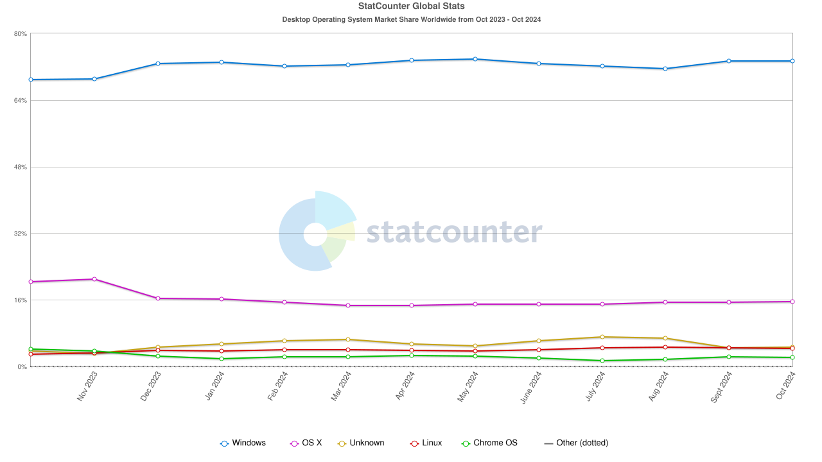

Figure Market Share of Desktop Operating Systems

#### Hardware

These VSBs initially rely on consumer-grade (or prosumer) equipment to save on costs. Frequently the router/firewall is a consumer-grade device provided to home networks with limited functionality. One early upgrade made to security is replacing or supplementing the consumer grade device with a more robust device that supports more features and in-depth protection..[46] ,[47]

Table Comparison of Consumer and Commercial Grade Routers

|  |  |  |
| --- | --- | --- |
| Feature | Consumer-Grade Modem/Routers | Low-End Commercial Grade (e.g., Sophos X85) |
| Firewall Protection | Basic NAT firewalls; limited rule customization | Advanced stateful firewalls with deep packet inspection |
| Intrusion Detection/Prevention | Generally absent or very basic | Integrated IDS/IPS for real-time threat detection |
| VPN Support | Simple VPN pass-through (e.g., PPTP, L2TP/IPSec) | Full VPN support including SSL VPNs and site-to-site IPSec |
| Antivirus/Anti-malware | Rarely included | Built-in threat protection capabilities with updates |
| Web Filtering | Minimal parental controls | Advanced web filtering with customizable categories |
| User Management | Limited user roles and device tracking | Comprehensive user and device management with logging |
| QoS and Bandwidth Control | Basic QoS; not highly customizable | Enhanced QoS with traffic shaping and detailed policies |
| Secure Remote Access | May allow basic remote management; lacks security | Secure remote admin access with multi-factor authentication (MFA) |
| Software/Update Support | Sporadic updates, often vendor-dependent | Regular, security-focused firmware updates |

Wired networks also include network switches providing from 4 to 36 connections each (or more) to interconnect wired connections as needed. Such devices at this level are typically unmanaged and do not attempt to regulate the data flow through the device.

Some offices may use either direct attached storage (DAS) or a Network-Attached Storage (NAS) device for file sharing and backup if a dedicated server is too costly (Tyson, 2023).

One underrated capability of NAS devices is that some (e.g., Synology) provide a host of added capabilities and services such as automated back-up, redundant array of inexpensive drives (RAID) providing fault tolerance, and the ability to perform as a low-end domain server with DNS, DHCP, user authentication, and virtual machine (VM) hosting. While a NAS provides excellent capability for their modest cost, their primary limitation is they may not be capable of supporting large domains because most lack two major requirements: FIPS 140 encryption and a Security Technical Implementation Guide (STIG). More on this later.

### Network Typology - Domain vs. Workgroup

Initially VSB network users tend to rely on unmanaged peer-to-peer workgroups[48]. They then progress to managed domains once a certain size is reached – typically in the range of 10 – 20 endpoints or users. At that point a transition to a domain typology is common - sometimes with a central server for shared file storage. The storage can be located on either the domain server, cloud storage, or a network attached storage appliance/file server.

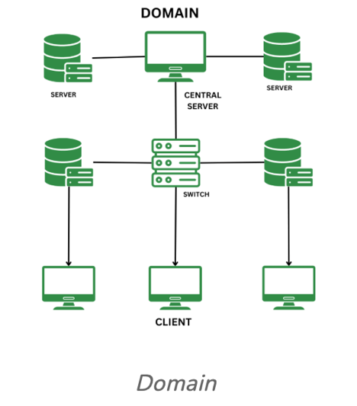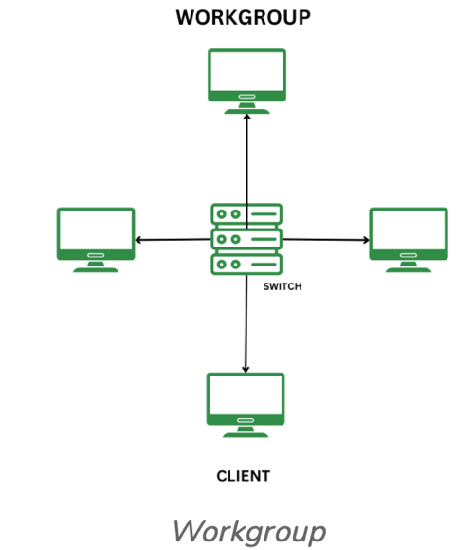

Figure Domain vs. Workgroup

Domains are preferred over workgroups in offices with 10 or more users as they offer centralized management, the ability to use common account credentials across the network, granular permissions for file access or other operations, easier patch management, and enhanced security.

Domains may be controlled by a physical server such as an on-premises device or through a virtual domain server such as provided as part of the Microsoft 365 enterprise suite. The controller – as the name implies – manages such activities as identity verification and permissions for users, enforcing network or business policies, and providing multiple services needed for network operation such as translating domain names to addresses or managing a pool of assignable network addresses.

Table Server typologies common to very small businesses i.e., < 20 employees

|  |  |
| --- | --- |
| Server Type | Percentage of Small Businesses (0–20 employees) Utilizing |
| Cloud Servers (e.g., SaaS like MS 365) | ~42% of small businesses use cloud-based services to manage operations and reduce costs. This includes software, storage, and computing resources. The trend is projected to grow as more businesses migrate their workloads to the cloud. |
| On-Premises Servers | ~20% of smaller businesses still rely on on-premises servers. This choice is often due to data security concerns, legacy systems, or specific industry requirements. However, there is a steady shift toward cloud solutions. |
| Hybrid Solutions | ~34% of small businesses use a combination of cloud and on-premises infrastructure. This model allows them to leverage the flexibility and scalability of cloud services while maintaining certain data or processes locally. |

## VSB Security Practices

Security in VSBs begins as a limited ad hoc capability characterized by basic measures such as firewalls (often embedded in the router), antivirus software, complex passwords, and occasionally a virtual private network (VPN) for remote access. Smaller businesses may not have specialized IT staff and often outsource cybersecurity or rely on managed service providers for periodic support (Small Business Administration, 2022).

### Anti-Malware and Endpoint Management

There are a multitude of anti-malware and security management software as a service providers at various price points.

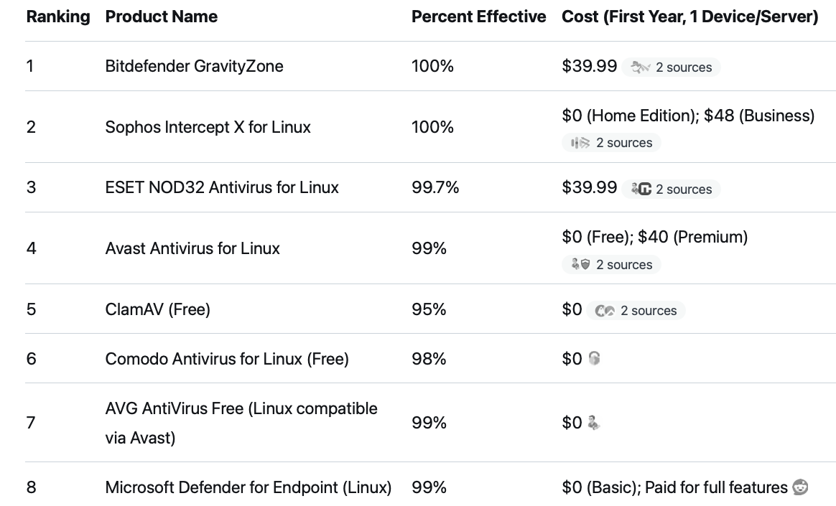

The choice of a product is often based on brand loyalty or personal preferences with zero-cost products offering adequate protection (especially considering the Linux OS preference in the CyberHygiene configuration) but some of these products offer added value such as end-point management, vulnerability assessments etc. My two recommended choices for VSBs interested in CMMC compliance are BitDefender Gravity Zone and Sophos Business. For lesser requirements any of the listed products will suffice.

One important side note is that products from Kaspersky are expressly forbidden by federal regulation on systems used by government contractors!

### Cloud-Based Services

To reduce the need for extensive on-site infrastructure, many small businesses use cloud-based applications for email, file storage, and collaboration. Services like Microsoft 365, Proton Mail, or Google Workspace are popular as they offer secure, scalable options without significant upfront costs (O’Brien & Marakas, 2021).

One significant factor when choosing such cloud-based services is the question of “where will your FCI or Controlled Unclassified Information (CUI) reside”? If the answer involves cloud-based services then the standard commercial offering will not meet standards. To be compliant the service must be a Federal Risk and Authorization Management Program (FedRamp) approved cloud provider from the FedRamp Marketplace.[49] This includes email and cloud back-up. Such services are very expensive[50] and generally require an existing government contract with CUI requirements to qualify for on-boarding. Consequently, some VSBs choose to work around such cloud-based solutions via self-hosting and limiting CUI or FCI transfers to using government or prime contractor provided secure portals.

### Backup and Recovery

Small businesses often use basic backup solutions, such as external hard drives or cloud backups, for data protection. While some adopt automated solutions, others rely on manual processes due to budget limitations (Delgado, 2022). The wide availability and low cost of network attached storage appliances (NAS) many of which are bundled with automated back-up software is an economical choice as a primary backup and may be combined with cloud or direct attached storage devices (e.g., USB drives) or server-based storage to provide a robust back-up solution.

Again, while many of these solutions are more than adequate for commercial requirements, as we will see, they may not pass muster when FCI or CUI are required. More on that later

## Choosing a Network Typology – the Pros and Cons

### On Premises or Virtual Server

For very small businesses with fewer than 20 employees, on-premises servers are relatively uncommon, with adoption rates estimated between 10% and 25%[51]. This trend is largely due to the growing availability of cloud-based services that minimize the need for physical servers by offering scalable and cost-effective cloud-based solutions.

Cloud-based platforms like Microsoft 365, Google Workspace, JumpCloud, and other virtual domain services products are popular among small businesses due to their flexibility, lower upfront costs, and minimal maintenance requirements. These services reduce the dependency on physical servers, making them attractive to very small businesses with limited IT budgets and technical expertise (Delgado, 2022; Teal Technology Services, 2024). As stated above, if these services are to be used for government contracts, especially at Level 2, the must be FedRamp approved which eliminates JumpCloud.

Some small businesses do maintain a server – often for specific reasons, such as data security, regulatory compliance (as would be the case with FCI or CUI), or the need for local data access. Sectors handling sensitive information, like healthcare, government contracts, or finance, may prioritize physical servers to meet regulatory requirements and ensure a higher level of data control (Cloudwards, 2023)[52]. For others, the high initial cost and ongoing maintenance of physical servers often outweigh the perceived benefits, making cloud services the preferred alternative (O’Brien & Marakas, 2021)[53].

For very small businesses considering a transition to a cloud-based solution like Microsoft 365 E5 or Government GCC High versus an on-premises server, a financial analysis of initial and ongoing costs is essential. Each option has distinct financial implications, including setup costs, migration expenses, and recurring fees, with cloud solutions typically offering better scalability but potentially higher long-term expenses.

#### On-Premises Server:

Establishing an on-premises server can involve significant initial costs for hardware, software, installation, and configuration. However, there are strategies available to limit these costs such as a Linux server based on older or low end technology and open-source software. This is a viable solution for those willing to break with the Microsoft ecosystem – and one that has been adapted enthusiastically by the CyberHygiene Project in its lab environment.

Small businesses may also need to budget for licensing fees and IT support to manage and maintain the server, which can add up substantially over time (SBA, 2022; Teal Technology Services, 2024)[54]. These expenses are one-time in nature may be amortized over several years, reducing their annual financial impact. Low-cost options are available including the afore mentioned Synology NAS (if NIST compliance is not a factor) or a Linux device scaled for the entity’s requirements.

#### Cloud-Based Domain Servers

Migrating to a cloud-based domain services such as Microsoft 365 GCC High ostensibly requires a smaller initial investment since there’s no hardware to purchase. However, businesses may incur significant start-up and migration costs, especially if data transfer, account setup, and system integration require professional services. Microsoft and third-party providers may charge setup fees, though these are claimed to be lower than those for physical infrastructure (Microsoft, 2022).

One noted issue with the Microsoft cloud approach is the multiple offerings, SKUs, and somewhat obscure product names that tend to channel potential clients into consultants who then prescribe the correct items, quantities, and SKUs to purchase and then charge a hefty fee to configure the product and on-board the client tenant. Since much of this information is very esoteric, the consultants tend to stay on as managed service providers. This situation tends to breed vendor lock-in making the client dependent long-term on the consultant.

One possible solution for very small businesses is to use a non-Microsoft virtual domain controller such as Keeper or Jump Cloud for domain management services, however these services will need to be FedRamp compliant should CUI be present (Level 2) which limits cloices and elevates the cost significantly.[55]

### Monthly Subscription Fees vs. Long-Term Maintenance

#### On-Premises Server:

While an on-premises server doesn’t incur ongoing subscription fees, it does require regular maintenance, updates, and potential future upgrades. The choice of operating system and open source vs commercial solutions will be a significant factor in these recurring costs with Open Source solutions tending to be either free or inexpensive and commercial services priced on a monthly or annual basis.The cost of electricity and cooling for the server room also adds to operational expenses (Delgado, 2022).

#### Cloud-Based Solutions:

Cloud services like Microsoft 365 E5 offer predictable monthly fees, covering software updates, IT support, and infrastructure maintenance. This can simplify budgeting for very small businesses that prefer predictable expenses and managed services. However, long-term subscription costs can be substantial.

### Scalability and Flexibility

#### On-Premises Server:

Expanding on-premises server capacity could require purchasing additional hardware and possibly increased licensing costs. This can limit growth or add unexpected expenses for a growing small business (Cloudwards, 2023). For example, RedHat Enterprise Linux (RHEL) has a basic license fee of $383.00 per year exclusive of technical support. Standard support costs start at $878.00/year and go up to $1813.90/year per server.[56] Total cost per year/server is on the order of $1,250 to $2,200. However, essentially the same product as RHEL is available for free through open-source software branded as CentOS or Rocky Linux limiting cost to support services only. [57]

Support for open-source products is generally via community support or via a locally retained MSP. Some providers do offer paid support although pricing is not advertised. One interesting development is the role of AI in this respect. Using services such as Grok or ChatGPT as a DIT solution to resolve minor technical glitches is reasonably effective and free or low cost depending on licensing agreements with the AI host.

#### Cloud-Based Solutions:

Microsoft 365 E5 is highly scalable, allowing businesses to add users or services without purchasing additional hardware. This flexibility is beneficial for growing businesses, as it provides IT resources on demand and minimizes capital expenditure risks. However, 365E5 does not meet NIS 800-171 Level 2 requirements. Cost is on the order of $30 to $50/per user per month or $360 to $600/year exclusive of support services. Typically, such packages include a minimum user count

## Virtual Device (or Desktop) Interfaces (VDI)[58]

One promising scenario for VSBs needing limited access to CUI is to implement a dedicated virtual desktop or connection to a secure platform and limit all CUI to that device. This is possible as a virtual desktop hosted on a CMMC compliant cloud-based network but there are certain limitations to the approach that must be factored into the decision.

A VDI provides a user with the ability to connect to a secure host over an encrypted (typically VPN or similar) connection. Once connected they have a web-based interface to a remote desktop in a secure enclave. They can have a separate email account that is secured to permit transmitting or receiving CUI or other sensitive material, access to various shared services such as SharePoint or shared file systems, and the ability to work in browser-based editions of common office products like Word, Excel, etc.

In this environment CUI is never allowed off the remote platform onto the local machine thus preserving the security of the protected content. Therefore, the local user cannot usually save to their desktop, print, or email documents to prohibited external accounts.

Although a VDI offers a secure environment it comes with some limitations. Here is a cost estimator from one VDI provider that illustrates their pricing for a VDI meeting DFARS requirements of $2,500/month or $3,000/year for a single user.[59] Such estimates tend to be subject to minimum user requirements such that a $500 per user per month rate becomes a $4,000 per month or 48,000 per year rate once the minimum of 5 users is factored into the cost.

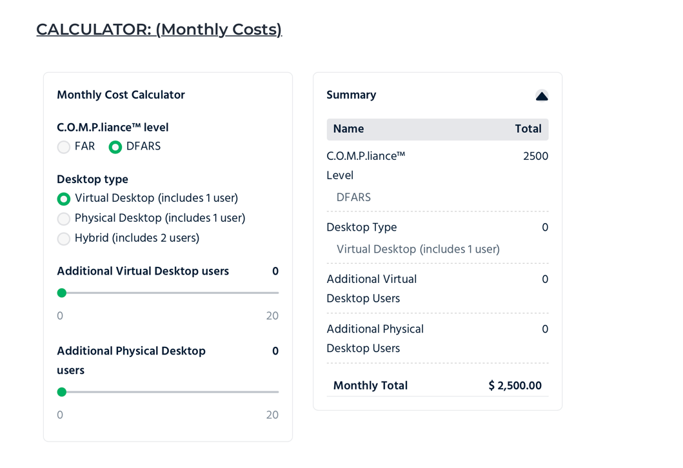

Figure Estimated Monthly Cost for Viirtual Desktop

One of the principal limitations for VDIs occurs in the scientific and engineering community where specialized software products are used for simulation and analysis. The software suite supported by the VDIs may be limited to a defined set of tools and if those tools are not supported the user is constrained in their ability to work on projects that generate or process CUI. Similar issues arise in other areas where specialty software is common including desktop publishing, video production, and proposal generation.

Those applications that use a back-end database will find the VDI environment difficult unless the database is hosted behind the VDI firewall i.e., inside the protected domain. That is just not commercially practical for VDI solutions such as the one illustrated above. It also raises the specter of having FCI or CUI outside of the defined system scope and requiring the cloud based provider to be both FedRamp and CMMC certified. Finally, the cost per seat can be prohibitive for a VSB should they need to provide multiple users access to the service.

1. Building a VSB Cyber Compliant Workstation

Workstations are the building blocks of a business network. They can be either a desktop system or a portable (laptop) computer that is configured for a specific type of work – be that CAD, video editing, or general office tasks. More importantly, this can be the only device in a VSB with a single proprietor – something I call a solopreneur. Nonemployer firms—defined as businesses without paid employees and generally operated by a single person—comprise 81.9% of all U.S. small businesses overall.[60] Some 32,679[61] unique small businesses received one or more contracts from the DoD in 2024. Of these, roughly 25,000 are under 15 employees and more than 20,000 are believed to be solopreneurs – or in SBA terms “nonemployers”[62]

Consequently the solopreneur segment is fertile ground for a low-cost cyber compliant workstation since such a device would fulfill the majority of Level 1 Cyberhygiene requirements for over 60% (12,000) of the one-person companies in the DIB and countless more in other Government Contracting domains. The remaining 13,000 small business will lokely need more than this bare-bones solution, but the good news is the same workstation can be used in conjunction with other hardware, as a nucleus of a larger or more secure (Level 2) aapplication.

## Ditching Microsoft for Open-Source Solutions

While there is a strong presence of Microsoft products in the government business sectors the typology of a typical Microsoft network with a network server/domain controller and various windows-based PCs is becoming a challenge to operate and maintain. The plethora of Microsoft products and services combined with their business practices is alienating a significant portion of their user base.

Setting up a turn-key network environment using Microsoft products and services – especially when such a network must be secured to NIST SP 800-171 standards to process government CUI is expensive and time consuming. Microsoft’s reliance on the Government Computing Cloud (GCC) High creates a significant financial drain for the intended Cybersecurity In a Box implementation.

Per a recent AI Search:

Windows 11 has been a focal point for privacy discussions since its 2021 launch, with criticisms echoing those of Windows 10 but amplified by new AI integrations and stricter account requirements.

Microsoft positions the OS as "privacy by design," compliant with standards like GDPR, and emphasizes user controls. However, experts, users, and regulators argue that default settings favor data collection for personalization, ads, and AI training, often making it hard for average users to fully opt out.

As of August 2025, concerns persist despite updates, including the controversial Recall AI feature, which screenshots your screen every few seconds for searchable history. Independent tests show it can still capture sensitive data like passwords or credit card numbers, even with filters. These issues aren't unique to Microsoft—Apple and Google face similar scrutiny—but Windows 11's mandatory online features and telemetry (data sent to Microsoft for diagnostics) make it more intrusive by default. Public sentiment on platforms like X (formerly Twitter) and Reddit often labels it "spyware," with users citing forced Microsoft accounts and persistent tracking. Recent X discussions (e.g., from August 2025) highlight Recall's rollout as a "privacy nightmare," prompting apps like Signal and Brave to block it.”

## If not Windows, then what?

To someone who cut their teeth on a Vic 20 back in 1982 the idea of using a ‘different’ operating system comes naturally. While I still have Widows installed on my work computer and use it as a VM on my ‘primary’ (Apple) computer; operating systems are just another piece of software. I have learned, used, and forgotten many of them including Commodore 64, CPM, Unix, TPM, VMS, RSX, DOS, OS2, Windows, Windows 386, Windows for Workstations, Windows NT, Windows Server etc. The idea that there might be a better tool in the toolbox than Windows 10/11/Server 20XX is not foreign.

From a user perspective, the Graphical User Interface (GUI) has tamed many of the objections to using other operating systems—especially Linux-based products like Ubuntu or Red Hat. For those already familiar with the environment, please bear with me during this brief segway.

What we know today as “modern” operating systems with a mouse and GUI started back at Xerox’s Palo Alto Research Center (PARC) when the mouse (invented by Douglas Engelbart) was combined with a bit mapped screen to create a GUI for the Xerox Alto computer circa 1973. *The modern*[*WIMP*](https://en.wikipedia.org/wiki/WIMP_(computing))*(windows icons, menus, and pointer) GUI was first developed at Xerox PARC by*[*Alan Kay*](https://en.wikipedia.org/wiki/Alan_Kay)*,*[*Larry Tesler*](https://en.wikipedia.org/wiki/Larry_Tesler)*,*[*Dan Ingalls*](https://en.wikipedia.org/wiki/Dan_Ingalls)*,*[*David Smith*](https://en.wikipedia.org/wiki/David_Canfield_Smith)*,*[*Clarence Ellis*](https://en.wikipedia.org/wiki/Clarence_Ellis_(computer_scientist))*and a number of other researchers. This was introduced in the*[*Smalltalk*](https://en.wikipedia.org/wiki/Smalltalk)*programming environment. It used*[*windows*](https://en.wikipedia.org/wiki/Windowing_system)*,*[*icons*](https://en.wikipedia.org/wiki/Icon_(computing))*, and*[*menus*](https://en.wikipedia.org/wiki/Menu_(computing))*(including the first fixed drop-down menu) to support commands such as opening files, deleting files, moving files, etc [63]*

Microsoft and Apple essentially cloned the Xerox concept when developing the Lisa (Apple 1978) and Windows (1985). Many others jumped on the bandwagon (including Amiga, Tandy, IBM, Epson, and Digital Research) and marketed their own incarnations of the GUI over the coming years. Consequently, computers morphed from character-based to GUI interfaces to the extent that very few character-based operating systems remain – or at least exist without an optional GUI.

So, the primary differentiator that made Windows what it is today (the GUI) is no longer a rarity – it is *de rigueur*. But that’s like saying every car has turn signals and a steering wheel. What we ignore then is what’s under the hood – Linux vs. Windows. And it is here that the security mavens align with my selection of Linux.

Linux is often considered more secure than Windows by design due to:

* Open-Source Model: Linux's code is publicly accessible, allowing global scrutiny and rapid patching of vulnerabilities
* User Permissions: Linux enforces strict user privilege separation, with most processes running as non-root, limiting potential damage.
* Diverse Ecosystem: Varied distributions and configurations make it harder for attackers to target a uniform system.
* Smaller Attack Surface: Linux often ships with minimal software, reducing exploitable entry points compared to Windows' broader default installations.
* Community-Driven Updates: Frequent, decentralized updates from the open-source community address security issues quickly.

Linux is common than Windows in government and high-security systems, especially for servers, critical infrastructure, and privacy-focused applications. Its open-source model, strict security features, and customization make it the go-to choice for secure environments, while Windows is primarily used in desktop settings or where proprietary software is necessary. Linux’s strict user privilege model, modular architecture, and features like SELinux, AppArmor, and seccomp make it a preferred choice for high-security environments. Its open-source nature enables rapid vulnerability identification and patching, critical for secure systems. Linux powers most of the world’s supercomputers and high-value devices, where security is paramount. However, both systems require proper configuration and maintenance to maximize security, as misconfigured Linux systems can still be vulnerable.[64]

OpenSCAP plays a critical role in hardening Linux systems and ensuring system security by providing a standardized, automated framework for assessing, configuring, and maintaining compliance with security policies. OpenSCAP provides automated compliance checking, vulnerability scanning, and remediation to meet rigorous standards. Its role is especially critical in government and high-security environments, where Linux’s prevalence demands robust tools to maintain a secure posture. Compared to Windows, OpenSCAP benefits from Linux’s open-source ecosystem, offering greater transparency and flexibility for securing systems. For implementation, organizations can access OpenSCAP’s free resources or integrate it with enterprise Linux distributions like Red Hat, which often include built-in OpenSCAP support.[65]

From a strictly pragmatic point of view Linux is the operating system of choice when dealing with secure enterprise environment. However, this viewpoint is often at odds with many users who prefer the familiar cocoon of the Windows and Microsoft 365 environment – especially when it comes to playing games.

The ‘playing games’ opens pandora’s box – alluding to the tendency to mix personal and business usage on a single computer. That is a horrible practice and one that has many security implications. Better have two systems – one for work, one for personal use.

It is here that another Linux attribute arises. Linux runs on very modest hardware – often flourishing on the cast-aways created by the ever-increasing baseline requirements for Windows. From Grok AI[66]

**Business Use Considerations**:

* **Performance**: Linux is highly efficient, running well on older or low-spec hardware. Lightweight distributions (e.g., Xubuntu, Linux Mint) can handle office tasks (LibreOffice, Thunderbird) on systems with 4 GB RAM and dual-core CPUs. Modern distributions like Ubuntu or Fedora benefit from 8-16 GB RAM and SSDs for multitasking and enterprise tools (e.g., Google Workspace, Nextcloud).
* **Compatibility**: Linux supports a broad range of hardware, including legacy systems unsupported by Windows 11, making it ideal for businesses with diverse or older fleets. ARM support (e.g., Raspberry Pi, Apple M1 via Asahi Linux) adds flexibility for modern devices.
* **Cost**: Linux runs on inexpensive hardware (e.g., $300-$500 PCs or refurbished systems), and free distributions reduce software costs. Enterprise versions like RHEL require subscriptions (pricing at [https://www.redhat.com](https://www.redhat.com/)), but open-source alternatives (e.g., CentOS Stream, Rocky Linux) are free.
* **Software Demands**: Open-source office suites (e.g., LibreOffice, OnlyOffice) and email clients (e.g., Thunderbird, Evolution) are lightweight, requiring less RAM and storage than Microsoft 365. Browser-based tools (e.g., Google Docs) have similar requirements across OSes.
* **Security**: Linux’s modular design and strict privilege separation (as discussed previously) reduce resource demands for security tools. OpenSCAP and SELinux, common in CMMC environments, run efficiently on modest hardware (e.g., 4-8 GB RAM), unlike Windows’ heavier endpoint protection suites.

## Selecting the Hardware and Software

In the 18 months since that article was published, I have drilled down into the problem and narrowed the scope to a near laser focus for my first (hopefully of many) release of a beta product. The focus of this product is a sole proprietor, consultant, or solopreneur. Their characteristics include a one-person operation that is frequently home based. Consequently their cybersecurity needs are relatively modest since their scope typically is limited to a single easily secured room or office, a single computer device, and a WAN connection.

Thus, I began development on a single-user workstation (or possibly one that could be shared) with the following characteristics:

### No Microsoft Windows.

Microsoft Windows and the Microsoft ecosystem were rejected because (as described above) the hardware requirement limited Windows 11 to more expensive modern equipment and because of a number of privacy concerns expressed by knowledgeable IT professionals in various blogs. This led to the decision to look elsewhere, and that led me to Linux. The chief characteristics of Linux that made it attractive were modest hardware requirements, large library of free and open-source software, and no license costs.

### Choosing the Right Linux Distribution

Linux is a very popular operating system for engineers and STEM communities and is widely used in business enterprises due to its perceived ruggedness, reliability, and inherent security. While no operating system is immune to security breaches, Linux has a much better track record than Windows and is even slightly better than Mac OS (which has a common parentage). The Linux marketplace is populated by various distributions such as RedHat, Ubuntu, CentOS, Fedora, Debian, end others. This made the choice of a distribution problematic.

Eventually I settled on a rather new distribution known as Rocky Linux a “free, open-source operating system that is a binary-compatible fork of Red Hat Enterprise Linux (RHEL). It was created as a community-supported alternative to CentOS after Red Hat discontinued it, aiming to provide a stable and production-ready environment for servers and desktops.”[67] Rocky Linux **is** an open-source enterprise operating system that is 100% bug-for-bug compatible with Red Hat Enterprise Linux®. It offers stability, updates, support, and migration tools for free, and is backed by a community of sponsors and partners.[68]

Rocky’s main claim to fame is that it is a near perfect duplication of segment leader Red Hat Enterprise Linux® (RHEL). This means many of the security tools and adaptations present in RHEL are directly portable to Rocky. The second factor that raised it above runner-up Ubuntu (which also has a tremendous library of security-enhancing features) was the installer program for Rocky is much more user-friendly and robust than the equivalent installer in Ubuntu and better supported the complex disk partitioning scheme needed for NIST compliance.

## Building the Beta Systems

Building the beta systems was divided between selecting and obtaining the required hardware and then loading and configuring the software.

### Beta System Hardware

Unlike personal systems that often are built for gaming or other fun activities, business workstations tend to be bland.

Business owners should have at least two computer systems – one for work only and a second for personal or recreational purposes. Sharing a single computer for both business and work introduces significant risks and is likely to be in contravention of corporate security policies.

As said earlier, Linux has very modest hardware demands – especially when used for work. Consequently, when I shopped for a desktop system I looked for low-end desktops 1 to 2 generations old with enough performance to meet the recommended specs without breaking the bank.

I opted for what is known as a 1 liter (that’s about its volume) small form factor computer that was not made in mainland China and that was available in quantity in the used market (eBay). My Choice: The Hewlitt Packard (HP) EliteDesk 800 G4.

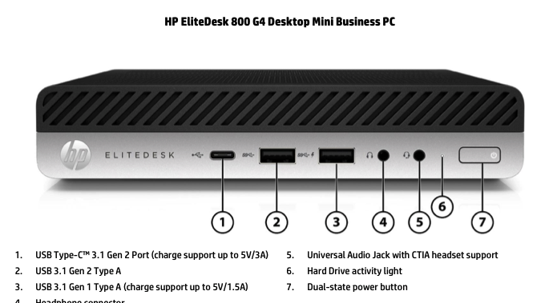

Figure , HP EliteDesk 800 G4 (Typical)

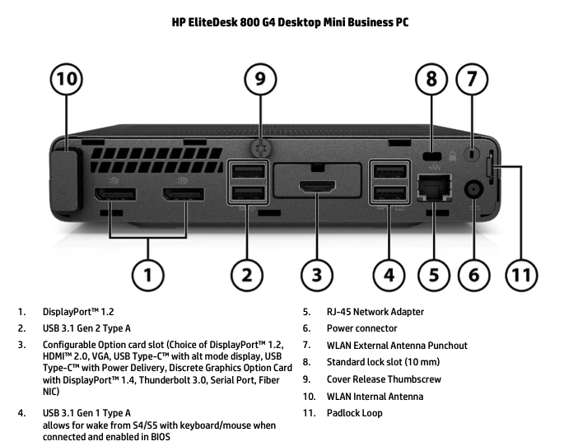

Figure HP EliteDesk 800 G4 Connectivity

Here’s how the 800 G4 stacks up to the equipment requirements:

Table , Beta System Hardware vs. Minimum Requirements

|  |  |  |  |
| --- | --- | --- | --- |
| Component | Minimum Requirement | Recommended for Workstation | Beta System |
| Architecture | 64-bit (x86_64, ARM64, ppc64le, or s390x) | x86_64 (AMD/Intel) for broad compatibility | x86_64 (AMD/Intel) |
| CPU | 64-bit processor (no specific speed listed; 1 GHz+ typically sufficient) | Multi-core (e.g., 2+ cores) at 2 GHz+ | 64 Bit Intel Core i5 or i7 processor 8th Generation 6 or 8 Cores 3 GHz with Hyperthreading |
| RAM | 1.5 GiB (for local media install; 3 GiB for network) | 4 GiB+ (8 GiB+ for heavy GUI use or virtualization) | 16 GiB minimum / 32 GiB DDR 4 |
| Storage | 10 GiB available disk space (unpartitioned or resizable partitions) | 40 GiB+ (SSD preferred for performance) | 256 GiB SSD Minimum, 512 GiB or 2 TB Optional |
| Graphics | 800 x 600 resolution support | 1024 x 768 or higher; dedicated GPU optional for advanced graphics | Intel UHD 630 supporting  4K (UHD): 3840 x 2160  2K (QHD): 2560 x 1440  Full HD (FHD): 1920 x 1080  HD: 1280 x 720 |

Another obvious benefit of these small systems is they are easily mounted on a wall, under a desk, or attached to the back of a monitor. They are also very power thrifty with electricity consuming roughly the same power as a desk lamp and producing about as much heat.

### Software

This is where weeks turned to months as I tried various software and operating systems – finally arriving at my preferred choices:

Table Beta System Software Stack

|  |  |  |
| --- | --- | --- |
| Product | Price | Use Case |
| OnlyOffice or Libre Office | Free | General office productivity, including word processing, spreadsheet, and presentations. Highly compatible with MS Office |
| ProjectLibre | Free | Replacement for MS Project |
| Thunderbird | Free | Full featured email client |
| SCAP Workbench | Free | Security configuration and testing application to identify and remediate system vulnerabilities |
| Rocky Linux 9.6 | Free | Latest stable release of Rocky. Version 10 is available by 9.6 was selected based on support by SCAP Workbench and others. |

For a detailed description of the installation process see Chapter 10 Rocky Linux Installation and Configuration. My strategy was to create a master duplication (Golden) disk which could then be used to set up additional systems by just duplicating the disk (see below)

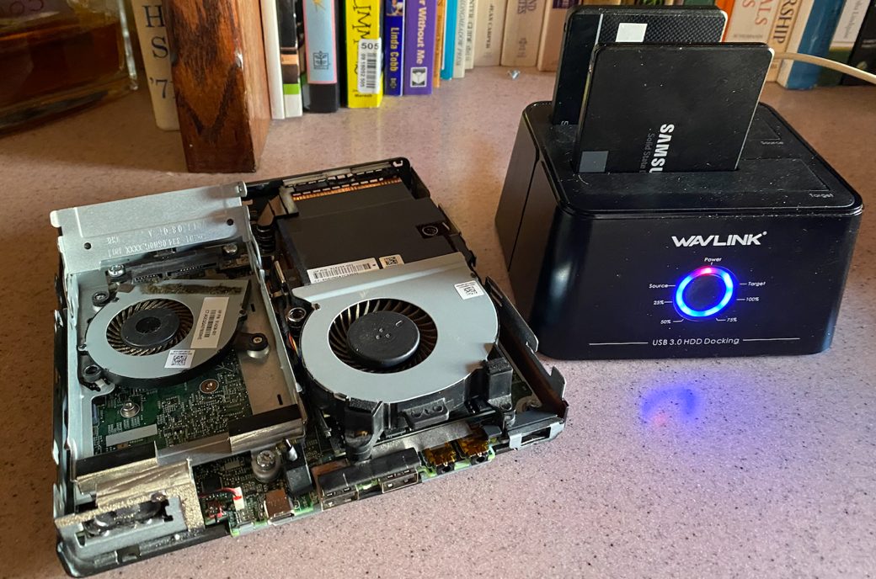

Figure , Ub-hooded HP EliteDesktop 800 G4 and WavLink Disk Duplicator

This method has been used by businesses for many years and consists of an installation disk or image that is properly configured with all the appropriate settings, updates, and choices pre-made for the user. This (golden) disk is the master for everyone using a particular hardware device or configuration and is maintained under strict configuration management by the administrator. If a computer has a corrupted disk, a virus infection, or a hardware failure the golden disk may be used to get the system back to a known starting place. Following that the system can be customized and specific applications loaded completing the initial or recovery system configuration.

Once the disk was duplicated it was largely plug and play – the common hardware being a blessing. I built three HP Desktops and two Dell Laptops using the same configuration for Beta Testers. I also retained two of the HP desktops for use in my Home Lab

## End Point Configuration and Hardening

Correctly configuring and hardening the various devices attached to the network is probably the most technical and time-consuming chores in the entire cybersecurity process.

Much of the effort is associated with hunting down and correcting (also known as remediating) various security flaws (or vulnerabilities) that exist in the system. Fortunately, there are several automated tools available that will assist the administrator or technician in performing this chore.

**WARNING**

System hardening involves making very detailed technical changes to the operating system or software – changes that are potentially damaging to the network or the system. These settings and their adjustment can result in system performance issues, system failure, and potentially loss of data. Consequently, these adjustments should only be done by a competent technician and should be preceded by a complete backup of the equipment to be configured to permit recovery should the configuration have undesired effects.  
  
You Have Been Warned!

## The origin of “vulnerabilities”.

Operating systems (OS) and commercial software are provided for the masses. As such they include several functions, features, and capabilities that are geared towards improving the user experience and driving advertising revenue to the software publisher. Such features often include convenient widgets or tools that display the news feed (sponsored by the software company who derives revenue from views and clicks), weather apps (same story), advertisements in browsers or software etc. Commercial operating systems and software also harvest vast amounts of data from users which generates added revenue streams.

Simply installing Windows 11 on a system may result in user data being generated and linked to a (mandatory) Microsoft account. There are ways to bypass such data collection attempts, but they do nothing to halt the OS from ‘phoning home’ every time you access certain functions. All this is under the guise of product improvement.

The unspoken price paid for these ‘bonus’ products or features is loss of privacy and potential for exploits by cyber criminals. So, the first task facing a business user who wants to improve security is removing these eavesdropping services or software from the system that just arrived from a retailer. There are two methods for accomplishing this cleanup described below.

A second source of vulnerabilities known as Common Vulnerabilities and Exposures (CVEs) which are tracked by MITRE Corp as a part of the CVE Program. MITRE describes it as: “The mission of the CVE® Program is to identify, define, and catalog publicly disclosed cybersecurity **v**ulnerabilities**[69]**. There is one [**CVE Record**](https://www.cve.org/ResourcesSupport/Glossary?activeTerm=glossaryRecord) for each vulnerability in the catalog. The vulnerabilities are discovered then assigned and published by organizations from around the world that have partnered with the CVE Program. [**Partners**](https://www.cve.org/PartnerInformation/ListofPartners) publish CVE Records to communicate consistent descriptions of vulnerabilities. Information technology and cybersecurity professionals use CVE Records to ensure they are discussing the same issue, and to coordinate their efforts to prioritize and address the vulnerabilities.”[70]

Securing systems then becomes an exercise in finding and correcting the various CVEs present on a network device. Although simple in concept the exercise often turns into a game of ‘Whack-a-Mole’ as CVEs are being discovered or retired daily. Consequently, there are a plethora of services and software that search out and remediate CVEs – or at least the ones that can be automatically fixed. More on that later.

## Endpoint Hardening

Endpoints are devices that connect to the network such as workstations, printers, network attached storage, routers, etc. They are the primary risk when assessing the network as they represent doorways into the system.

### Basic Input-Output Systems (BIOS)

The low-level software that provides the infrastructure tor computer operation is comprised of the Basic Input-Output System (BIOS). Traditional BIOS is what is known as ‘firmware’ and resides in a read-only memory device in the system’s hardware. Generally speaking the BIOS is a ‘set-it and forget-it’ proposition needing little attention other than the occasional upgrade. This is true as well for other devices such as printers, routers, storage devices, etc.

Modern systems implement specific security provisions starting at this foundational level by encrypting portions of this code and then comparing that copy with the copy attempting to start the system. This is called a ‘secure boot’ and relies on a ‘core root of trust’ and is a feature that can be toggled on-or off through system settings.[71]

During system hardening a vendor specific checklist is often run by a technician to assure critical security settings and features such as this are enabled by default in the system BIOS.

### Operating Systems – Microsoft Windows

Although not used on the CyberHygiene Project in its current form, I did a significant amount of research on how to harden Windows 10/11 before I made the Linux decision. This information is included as a reference for those who wish to travel that path.

Microsoft Windows is a very popular (75% + market share) operating system and is widely used in commercial applications and offices. The Windows product is available in multiple versions and editions. The most common being Windows 10 or 11 in either the Home, Professional, or server editions. The home editions lack many of the features and tools needed for use in a NIST environment and are thus not considered here. The server and professional versions are similar with the server edition have some additional features aligned with using it in a role such as a domain controller.

Hardening Windows using the available free tools is possible but technically convoluted. No single tool seems to do 100 percent of the required hardening task and novices (myself included) have found themselves locked out of their system and having to resort to wiping the disk and restarting the process following what seemed to be a casual mistake.

Windows hardening is also dependent on setting the contents of specific values in a database called the Registry using a very tech-oriented tool called the registry editor or Regedit. This is not a task for the novice as mistakes ate often impactful and immediate. Consequently, some automated tools (described below) are used frequently to manage critical settings. But even these are not without peril.

If you are considering a DIY project – be sure to back everything up and be prepared for potential loss of data, system corruption, or an unresponsive system.

YOU HAVE BEEN WARNED.

### Hardening Kitty

The free program Hardening Kitty (see <https://github.com/scipag/HardeningKitty>) has long been a staple in my toolkit and is key to creating a secure windows dwployment as it locks in a number of important security settings – some of which are not addressed by other tools. This tool is recommended for experts only as it is very powerful and is only usable from a command line interface i.e., PowerShell interface. The Cyberhygiene implications and use of this tool is to use it to create windows installation where initial hardening settings are applied.

### Windows Debloat.

Windows 11 – as distributed by Microsoft – is aimed at a specific user demographic. As a result, it has several features or functions configured for user convenience at the price of user security. This is not to say windows is inherently insecure – but it is configured in such a manner that consumer oriented and information sharing capabilities have been prioritized for “ease of use” or “customer experience” whereas our intent is to have a lean and highly secure implementation. Getting there requires disabling or removing many of the ‘convenience’ features in Windows 11. This is accomplished by windows debloat (see: <https://github.com/Raphire/Win11Debloat>) to produce a minimalistic version of the product. Similar images are available through CIS (<https://www.cisecurity.org/cis-hardened-image-list>) for virtual machines.

Another tool usable for debloating windows (and many other uses as well) is Chris Titus winutil (see <https://github.com/ChrisTitusTech/winutil>) which will remove the non-essential windows components from an installed image.

### Senteon

One service that has been used -but is not recommended because of duplication with another service – was the Senteon Hardening Software – an agent-based product that deployed and installed policies via registry or other settings to establish and maintain a secure configuration aligned with a chosen cybersecurity framework.

Although the product is highly effective in not only initially forcing compliance with a standard, it also monitors ‘drift’ of those setting from the baseline. The security standard used is not NIST SP 800-171 however, but CIS 8.0. Although the two are closely aligned, there are some differences as reported by Grok AI :

“… while both frameworks aim to enhance cybersecurity, NIST SP 800-171 is more rigid with specific settings for CUI protection in regulated environments, whereas CIS Controls v8 provide a broader, more adaptable set of guidelines for general cybersecurity across diverse sectors. “

From a practical standpoint some 82 percent of the NIST SP 800-171 controls may be directly mapped to CIS 8.0 so there is a good degree of overlap between the two. However, the NIST requirements based on Security Technical Implementation Guidelines (STIGs) are best implemented by having the settings aligned with the comparable CIS STIG Benchmark and the precise hardware and software where it is installed.

Informal testing conducted by the author using a combination of the Senteon benchmarks and other products achieved very compliant results when evaluated by the DISA STIG Compliance Checker and scored 100% for windows 10/11 and the Windows Firewall (which have separate STIGS). The downside of Senteon is cost and coverage.

1. Cost. The product is priced at $24/endpoint per year ($2/month) but has a minimum license quantity of 50 endpoints ($1,200/year). If the service is brokered by an MSP then it is probably a good deal. If not, the similar service bundled in BitDefender Gravity Zone (about 500+ for 20 endpoints/year plus extras) is a better deal.
2. Coverage. In the windows environment there are multiple STIGS that need to be reun against a system such as Adobe Acrobat, Google Chrome, MS 365, etc. Senteon does not yet offer 100 percent coverage for all the various STIGS that need to be addressed whereas Linux avoids this complication through system design and OpenSourcing of software code.

### Linux

Linux hardening is considerably faster, easier, and less expensive than the comparable Windows workstation or server. This is because of the efforts of OpenScap[72] which provides security policies for multiple releases of Linux. For example, RHEL 9 (and by extension Rocky Linux 9) supports the following security guides:

* [[DRAFT] Unclassified Information in Non-federal Information Systems and Organizations (NIST 800-171)](http://static.open-scap.org/ssg-guides/ssg-rhel9-guide-cui.html)
* [PCI-DSS v3.2.1 Control Baseline for Red Hat Enterprise Linux 9](http://static.open-scap.org/ssg-guides/ssg-rhel9-guide-pci-dss.html)
* [[DRAFT] DISA STIG for Red Hat Enterprise Linux 9](http://static.open-scap.org/ssg-guides/ssg-rhel9-guide-stig.html)
* [[DRAFT] DISA STIG with GUI for Red Hat Enterprise Linux 9](http://static.open-scap.org/ssg-guides/ssg-rhel9-guide-stig_gui.html)
* [CIS Red Hat Enterprise Linux 9 Benchmark for Level 2 – Server](http://static.open-scap.org/ssg-guides/ssg-rhel9-guide-cis.html)
* [CIS Red Hat Enterprise Linux 9 Benchmark for Level 1 – Server](http://static.open-scap.org/ssg-guides/ssg-rhel9-guide-cis_server_l1.html)
* [CIS Red Hat Enterprise Linux 9 Benchmark for Level 1 – Workstation](http://static.open-scap.org/ssg-guides/ssg-rhel9-guide-cis_workstation_l1.html)
* [Australian Cyber Security Centre (ACSC) Essential Eight](http://static.open-scap.org/ssg-guides/ssg-rhel9-guide-e8.html)
* [Health Insurance Portability and Accountability Act (HIPAA)](http://static.open-scap.org/ssg-guides/ssg-rhel9-guide-hipaa.html)
* [Australian Cyber Security Centre (ACSC) ISM Official](http://static.open-scap.org/ssg-guides/ssg-rhel9-guide-ism_o.html)
* [CIS Red Hat Enterprise Linux 9 Benchmark for Level 2 – Workstation](http://static.open-scap.org/ssg-guides/ssg-rhel9-guide-cis_workstation_l2.html)
* [Protection Profile for General Purpose Operating Systems](http://static.open-scap.org/ssg-guides/ssg-rhel9-guide-ospp.html)
* [ANSSI-BP-028 (enhanced)](http://static.open-scap.org/ssg-guides/ssg-rhel9-guide-anssi_bp28_enhanced.html)
* [ANSSI-BP-028 (high)](http://static.open-scap.org/ssg-guides/ssg-rhel9-guide-anssi_bp28_high.html)
* [ANSSI-BP-028 (intermediary)](http://static.open-scap.org/ssg-guides/ssg-rhel9-guide-anssi_bp28_intermediary.html)
* [ANSSI-BP-028 (minimal)](http://static.open-scap.org/ssg-guides/ssg-rhel9-guide-anssi_bp28_minimal.html)

All an administrator need do is install the OpenSCAP workbench app (free) and select the appropriate security guide (RHEL 9) and profile “Unclassified Information in Non-federal Information Systems and Organizations (NIST 800-171)” and the workbench does the heavy lifting.

The OpenSCAP Workbench uses the Security Guide and profile to scan the target system, identify misconfigured settings, and make immediate remediations for the vast majority of problems. Those that cannot be fixed on the spot can be corrected with explicit instructions or snippets of code provided by the tool. Done.

### Linux Application Hardening

Application hardening is typically covered by the frequent updates and patches to apps by the open-source community and enhanced by tools such as security enhanced Linux (SELinux) and AppArmor. Both provide Mandatory Access Control (MAC) mechanism but are mutually exclusive – one or the other may be used – but not both.

MAC is a security model that enforces strict, centralized policies to regulate access to resources, such as files, directories, or network services. MAC) enhances security by enforcing strict, system-wide policies that confine applications - regardless of their source or intent - to predefined boundaries. The appropriate package (AppArmor or SELinux) is installed as a part of the OS hardening using OpenSCAP.

Should a third-party app (e.g., a downloaded utility, plugin, or service) attempt to "misbehave" (such as accessing sensitive files, escalating privileges, or exfiltrating data due to a vulnerability or malice), MAC intervenes at the kernel level to prevent and/or log these actions. This is a proactive defense, assuming the app can't be fully trusted. Unlike more flexible models, MAC does not allow individual users or resource owners to override these policies - access decisions are made solely by the system administrator or a central authority based on predefined rules, often tied to security classifications like sensitivity levels.

## Correcting Vulnerabilities and Misconfigurations.

Cyber criminals are opportunists – if they see an open door they will walk in and create mischief – or worse. As noted earlier, these ‘open doors’ are cataloged as CVEs and the correction process for closing off these various attack vectors is called ‘Hardening’.

A quick study of the below chart will identify the source or systems affected by known vulnerabilities (key exploited vulnerabilities) and should provide a basis of comparison when evaluating potential suppliers or software/hardware providers.

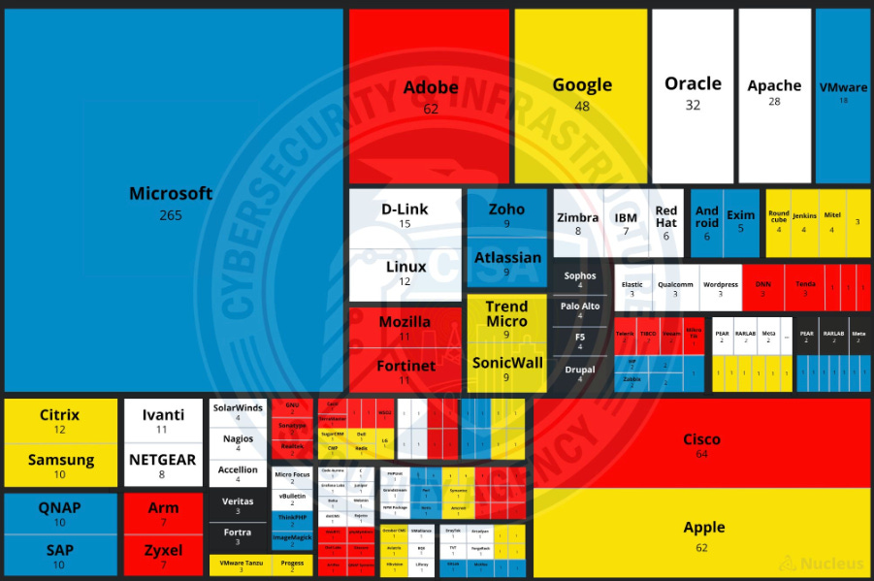

Figure Defense Information Security Agency - Key Exploited Vulnerabilities (October 2023)

## Baseline Maintenance

No discussion of end-point hardening and system configuration would be complete without acknowledging the dynamic nature of cybersecurity. It’s very much like the arcade game of “Whack-a-Mole” where every time you hit a mole another pops up in its place. Such is the nature of the cybersecurity task with new threats emerging daily and software developers releasing new versions of products as well as security updates (i.e., ‘patches’) on a near continuous basis.

New or emerging vulnerabilities are cataloged (as mentioned earlier) as CVEs. Here is a representative view of the volume of activity with respect to CVEs.

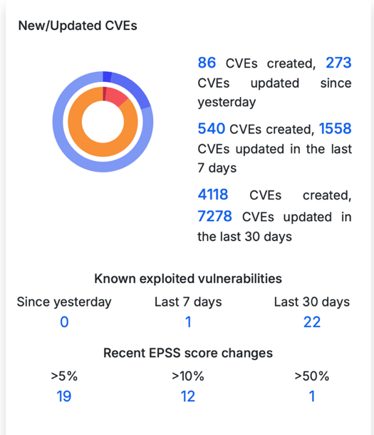  
Figure 12 CVE Activity for November 30, 2024 [73]

This leads to a situation where not only must a system be hardened to a specific baseline, it must also be consistently monitored and updated to kept at a desired level of protection. Hence the issue of software (and baseline) maintenance and management.

## Patching

Software vendors release updates to their products in several ways. New versions i.e., version 3.0 vs. version 2.0 are referred to as major releases and are often sold as a separate product. Minor releases i.e., version 3.1 vs version 3.0, are more frequent releases and usually correct issues to the previous release or incrementally add new functions or features. Patches, on the other hand are released much more frequently and are specifically aimed at remediating a security or functional flaw in the product.

Managing the multitude of patches in the global software environment is a big job – one best managed by software services such as Tenable, CrowdStrike, etc. The solution included in the CyberHygiene is provided as a component in the anti-malware and endpoint management suite called Gravity Zone from BitDefender.

Like most similar products the patch manager starts with an inventory of the software (both operating system and applications) installed on an endpoint and then monitors various sources for changes to those products.[74]

Solutions range from user initiated manual checks and updates to more fully automated patch management applications (or services) that automatically find and install patches on a daily (or more frequent) basis.

## Vulnerability Scanning

Working hand-in-hand with patching services we find vulnerability management products that monitor for new CVEs, assess the impact on your network or endpoint based on the installed software, and notify the system administrator of the threat. Vulnerabilities can be of two types:

1. Non-conformances to a system baseline i.e., drift or
2. New CVEs affecting your system or network.

The software generally advises of the vulnerability existing and then offers advice on either remediation (fixing) or mitigation (reducing the impacts of an attack.

Irrespective of the checklist used the requirements are the same: find and fix a long list of possible misconfigurations and then monitor the now hardened system to ensure the settings are not undone by users or subsequent software updates i.e., ‘drifting’ off the desired configuration.

Much of the heavy lifting for hardening the system to NIST SP 800-171 has been done via the preceding steps. The final step is to use the SCAP Workbench tool which we downloaded earlier to identify and remediate issues.

What we are looking for is the following report:

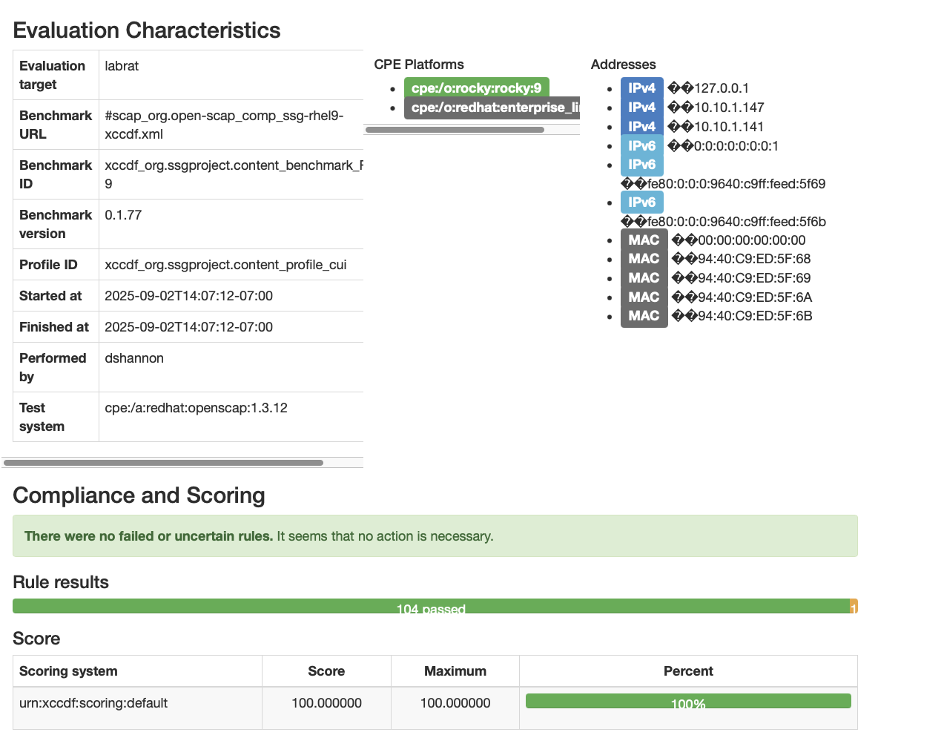



Figure , Sample OpenScap System Scorecard Report

Getting that 100 percent score is straightforward provided you followed the preceding steps to partition your drive and select the appropriate security profile during installation. The remaining steps are covered below.

1. Level 1 (Foundational) Network Approach

The below network architecture was developed for CMMC Level 1 compliance with NIST SP 800-171 (Foundational) using off-the shelf components and services with a maximum budget of $5,000.

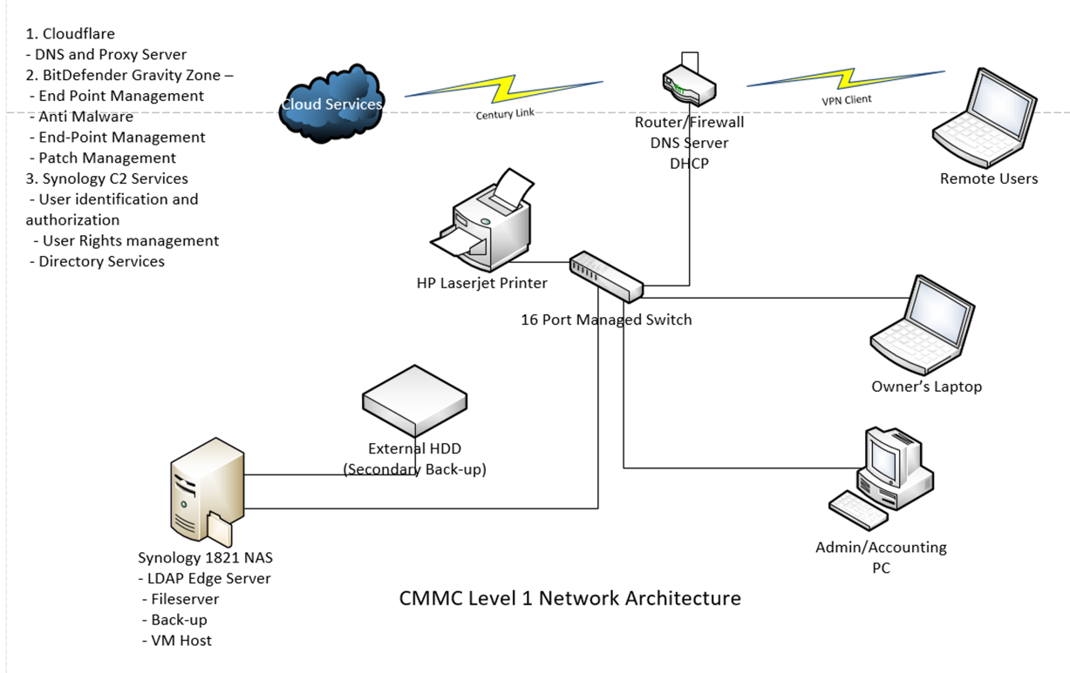

Figure Notional CMMC Level 1 Compliant Network

## Level 1 Domain Controller

The level 1 DC solution selected was value driven to provide the needed functionality at an affordable price. The DC comprises the following equipment and services. Where possible retail price estimates are included:

1. Donain Controller Hardware
   1. HPE Microserver Gen 10/11 (diskless) = $ 666.00
   2. 16 GB RAM (generic) *= $ 35.00
   3. iLo 5 Enablement Kit* = $174.00
   4. TPM Module* = $123.00
   5. 4 x 4TB HDD @ $149 ea = $596.00

**Total $1,594.00**

Items marked with * are included in Gen 11’s price of $1,159 along with additional improvements.

1. BitDefender Gravity Zone 10 endpoints with patch management and device encryption options $500/year
2. Cloudflare DNS and network monitoring service – Free
3. SSL Certificate - Free
4. Domain Name (Cyberinabox.net) $30/year

### Level 1 Components and Services

Other network components include a Firewall/router such as the Netgate 4100 ($549.00) and a 16 port switch such as the Netgear GS316EP ( $239) which can be used in either a managed or unmanaged role. Total cost for hardware and software is just over $3,100 plus installation and set-up. Well within the $5,000 budget established for Cybersecurity in a Box in my 2024 Journal of Contract Management article.

Table Level 1 System Summary of Features and Capabilities

|  |  |  |  |  |  |
| --- | --- | --- | --- | --- | --- |
| Feature or Capability | BitDefender Gravity Zone |  | Synology NAS / DSM[75], [76] | Cloudflare | Firewall |
| Cost per Year | $400/10 users | $0 | $0[77] | $0[78] | $0 |
| AntiMalware | √ |  |  |  | √ |
| Patch Management | √ |  |  |  |  |
| Endpoint Management (Policy Enforcement) | √ |  |  |  |  |
| User authentication and rights management |  | √ |  |  |  |
| Lightweight Directory Access Protocol (LDAP) |  | √ | √ |  |  |
| Multifactor Authentication |  | √ |  |  |  |
| Full Drive Encryption | √ |  | √ |  |  |
| Network Traffic Encryption -Transport Layer Security TLS |  |  | √ | √ | √ |
| Network traffic monitoring and Intrusion detection/reporting | √ |  |  | √ | √ |
| Dedicated Denial of Service protection |  |  |  | √ |  |
| Free SSL Certificate |  |  |  | √ |  |
| Virtual Private Network (VPN) support |  | √ |  |  | √ |
| Secure File Sharing and network traffic |  | √ |  | √ |  |

## Network Hardening Overview

The first step is to identify and correct known vulnerabilities by performing a complete scan of every endpoint on the network – including the Router, Switches, Computers (or servers) and virtual machines for an exhaustive list of possible vulnerabilities.

The list of vulnerabilities is called (among other names) a Security Technical Implementation Guide (STIG) which is “a configuration standard consisting of cybersecurity requirements for a specific product”[79] A repository of STIGs is maintained at the National Institute of Standards and Technology (NIST) at https://ncp.nist.gov/repository . An alternate source is the Center for Internet Security (CIS) who publish a series of CIS Benchmarks which are mapped (cross referenced) to the DISA STIGs and are acceptable for use for government systems (“While the use of STIGs and SRGs by CSPs is preferable, industry-standard baselines such as those provided by the Center for Internet Security (CIS) Benchmarks are an acceptable alternative to the STIGs and SRGs.”)[80]

## Level 1 Compliance

Once installed and set-up the network can be easily configured with the aid of policy templates into compliance with NIST SP 800-171 Level 1. It is important to note that the specified solution not only meets but exceeds the basic requirements in several areas. I would classify it as Level 1+ and approaching Level 2 requirements.

Table Level 1 System Compliance with NIST SP 800-171 Controls (pending update)

|  |  |  |  |  |
| --- | --- | --- | --- | --- |
| NIST SP 800-171 Control | Family | Description | Method, Tool or Product used for Compliance | Comments |
| 3.1.1 | Access Control | Limit system access to authorized users, processes acting on behalf of authorized users, and devices (including other systems). | Synology C2 Identity Management | C2 provides robust LDAP user authentication and rights management. |
| 3.1.2 | Access Control | Limit system access to the types of transactions and functions that authorized users are permitted to execute. | Synology C2 Identity Management | C2 provides robust LDAP user authentication and rights management. |
| 3.1.20 | Access Control | Verify and control/limit connections to and use of external systems. | BitDefender Endpoint Management and Firewall rules |  |
| 3.1.21 | Access Control | Limit use of organizational portable storage devices on external systems. | BitDefender Gravity Zone Endpoint Management |  |
| 3.5.1 | Identification and Authentication | Identify system users, processes acting on behalf of users, and devices. | Synology C2 Identity Management |  |
| 3.5.2 | Identification and Authentication | Authenticate (or verify) the identities of users, processes, or devices, as a prerequisite to allowing access to organizational systems | Synology C2 Identity Management | Includes multifactor authentication |
| 3.8.3 | Media Protection | Sanitize or destroy system media containing CUI before disposal or release for reuse. | Written Policy |  |
| 3.10.1 | Personnel Security | Limit physical access to organizational systems, equipment, and the respective operating environments to authorized individuals. | Written Policy |  |
| 3.10.3 | Personnel Security | Escort visitors and monitor visitor activity. | Written Policy |  |
| 3.10.4 | Personnel Security | Maintain audit logs of physical access. | Written Policy |  |
| 3.10.5 | Personnel Security | Control and manage physical access devices. | Written Policy |  |
| 3.13.1 | System and Communications Protection | Monitor, control, and protect communications (i.e., information transmitted or received by organizational systems) at the external boundaries and key internal boundaries of organizational systems. | Synology C2 Identity Management, BitDefender Gravity Zone Endpoint Management, and Firewall rules |  |
| 3.13.5 | System and Communications Protection | Implement subnetworks for publicly accessible system components that are physically or logically separated from internal networks. | BitDefender Gravity Zone Endpoint Management, and Firewall rules |  |
| 3.14.1 | System and Information Integrity | Identify, report, and correct system flaws in a timely manner. | Written Policy |  |
| 3.14.2 | System and Information Integrity | Provide protection from malicious code at designated locations within organizational systems. | BitDefender Gravity Zone Endpoint Management |  |
| 3.14.4 | System and Information Integrity | Update malicious code protection mechanisms when new releases are available. | BitDefender GravityZone | Automatic updates to security software plus patch management of applications |
| 3.14.5 | System and Information Integrity | Perform periodic scans of organizational systems and real-time scans of files from external sources as files are downloaded, opened, or executed. | BitDefender Gravity Zone Endpoint Management and Cloudflare | Scan frequency is set as a software function and then accomplished automatically on access of the data and systemwide on a time based function specified by the administrator. |

1. Level 1 Laboratory Implementation

The choices made in the notional system were made using a cost focused approach that would provide the best results without reliance on paid services. Consequently, with the exception of the anti-malware/endpoint management solution from BitDefender Gravity Zone, all products and services are either included in the initial purchase price or are free. This fits well with cost conscious VSB owners and avoids potentially pay-as-you-go monthly fees from SaaS providers including Microsoft 365.

The choice of hardware components was intentionally limited to brands manufactured outside China in deference to FAR 52.204-25 Prohibition on Contracting for Certain Telecommunications and Video Surveillance Services or Equipment.

# Server

Hardware was the easy part for me. I have built dozens of computers since becoming interested in them in 1982. As I said earlier Linux is quite capable of running on very modest hardware with many experimenters and home lab enthusiasts successfully running servers on little more than a nano PC or a Raspberry Pi. I splurged and opted for an existing HP MicroServer Gen 10+. Were I to start anew I would opt for the slightly more modern Gen 11 with its more modern processor, faster memory, and other enhancements.

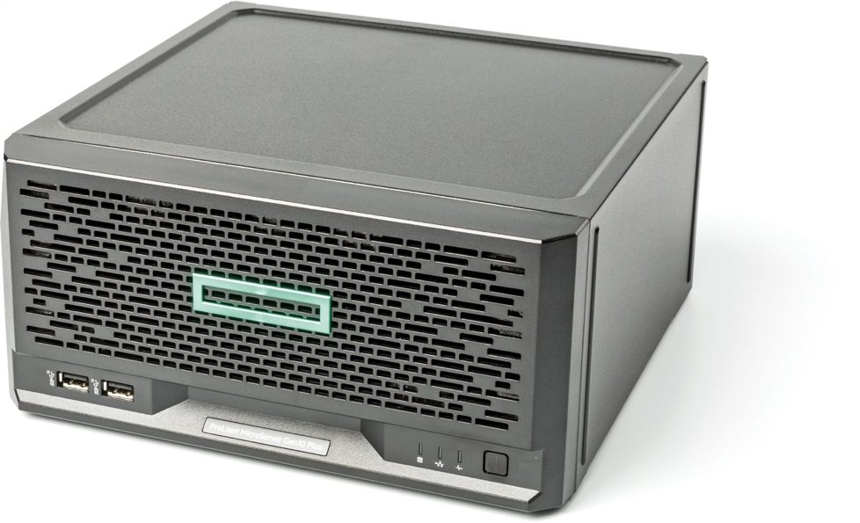

Figure , HP MicroServer Gen 10 Plus v2

Although lesser hardware such as the HP Elite Destop 800 series would easily handle the task I elected to upgrade to the more capable MicoServer, A list and comparison of their pertinent specifications is below.

Table MPE Microserver Gen 10 vs Gen 11 Comparison

|  |  |  |
| --- | --- | --- |
| Feature | HPE ProLiant MicroServer Gen10 Plus v2 | HPE ProLiant MicroServer Gen11 |
| Form Factor | Ultra Micro Tower | Ultra Micro Tower |
| Processor Options | Intel® Xeon® E-2300 Series and 10th Gen Pentium® G processors (up to 4 cores); Chipset: Intel® C252 | Intel® Xeon® 6300-series (up to 8 cores), Xeon® E-2400, Pentium® processors; Chipset: Intel® C262 |
| Memory | 2 DIMM slots; DDR4 UDIMM ECC; Max 64 GB (2 x 32 GB @ 3200 MT/s) | 4 DIMM slots; DDR5 UDIMM ECC; Max 128 GB (4 x 32 GB @ 4400 MT/s) |
| Storage | 4x non-hot plug 3.5" SATA bays; Max 16 TB HDD or 3.84 TB SSD; Intel VROC SATA Hybrid RAID | 4x non-hot plug 3.5" SATA bays; Max 16 TB HDD or 3.84 TB SSD; Intel VROC SATA Hybrid RAID |
| Networking | Embedded Intel i350 AM4 1Gb 4-port | Embedded Broadcom BCM5719 1GbE 4-port |
| Expansion Slots | 1x PCIe 4.0 x16 low-profile | 1x PCIe 5.0 x16 low-profile; 1x PCIe 4.0 x4 (x8 connector) low-profile |
| Power Supply | 180W external non-redundant | 180W or 330W external non-redundant |
| Dimensions (H x W x D) | 4.68 x 9.65 x 9.65 in (11.89 x 24.5 x 24.5 cm) | 6.06 x 10.28 x 9.82 in (15.4 x 26.1 x 24.9 cm) |
| Weight (Max) | 15.87 lb (7.2 kg) | 19.07 lb (8.65 kg) |
| Management | HPE iLO 5 (requires enablement kit) | HPE iLO 6 (embedded) |
| TPM 2.0 | Embedded, enabled by default (disabled for China) | Embedded, enabled by default (disabled for China) |
| FIPS 140 Support | Yes (FIPS 140-2 validation via iLO 5) | Yes (FIPS 140-2 validation via iLO 6) |
| Other Security Features (NIST-relevant) | UEFI Secure Boot & Secure Start; Immutable Silicon Root of Trust; Common Criteria certification; Firmware rollback; Secure erase; Configurable for PCI DSS | UEFI Secure Boot & Secure Start; Immutable Silicon Root of Trust; Common Criteria certification; Firmware rollback; Secure erase; Configurable for PCI DSS; Server Configuration Lock |

A quick review shows both systems are equally capable in a very small office environment with the Gen 11 having an advantage in terms of being more future-proof. Using the Microserver also allows access to a number of server only features in the hardware (like error correcting memory (ECC)) and a more robust BIOS.

Table HP Server vs Workstation BIOS comparison

|  |  |  |
| --- | --- | --- |
| Feature Category | HPE MicroServer Gen10 Plus v2 / Gen11 BIOS (UEFI System Utilities) | HP Z Workstation / Laptop BIOS (Commercial UEFI Setup) |
| Boot Modes | UEFI Mode (default) and Legacy BIOS Mode (Gen10); Gen11 primarily UEFI, Legacy support varies by model. Secure Boot and Secure Start enabled. | UEFI Mode (default); Legacy BIOS Mode supported on most models. Secure Boot available. |
| Interface & Navigation | Graphical UEFI interface with menus: System Configuration (BIOS/Platform Config - RBSU), One-Time Boot Menu, Embedded UEFI Shell, Boot Order, Network Options. Text-based options available. | Graphical UEFI interface with tabs: Main, Security, Advanced, UEFI Drivers. Mouse/keyboard navigation; simpler, more user-friendly for non-IT users. |
| Security Features | UEFI Secure Boot, Secure Start, Immutable Silicon Root of Trust, TPM 2.0 configuration, FIPS 140 support via iLO, firmware rollback, Common Criteria certification. BIOS Sure Start equivalent via iLO integration. | Secure Boot, TPM Embedded Security (with TPM Guard on newer models), BIOS Sure Start, Power-On/Administrator passwords, DriveLock, Secure Erase (NIST 800-88 compliant), Virtualization Based Protection. Pluton Security Processor on select AMD/Intel models. |
| Management Integration | Deep integration with HPE iLO (Gen10 requires kit, Gen11 embedded) for remote BIOS access, configuration, and updates. Supports mass deployment tools. | Intel AMT (Active Management Technology) for remote management on Intel models; USB Key Provisioning, Watchdog Timers. Less integrated than iLO; focuses on vPro/AMT for enterprise desktops. |
| Hardware Configuration | Extensive: Processor (hyper-threading, power profiles), Memory (ECC support), Storage (RAID/SATA options, VROC), Network (embedded NIC config), PCIe slots, Fan/Power profiles optimized for server reliability. | Processor (performance modes, hyper-threading), Memory (non-ECC typical), Storage (SATA/AHCI/RAID basic), Built-in Devices (USB/ports disable), PCIe/M.2 slots, Thunderbolt options. More focus on graphics/GPU tuning in workstations. |
| Power Management | Server-oriented: Static/Dynamic power capping, OS Control Mode, redundant PSU support, thermal profiles for 24/7 operation. | Workstation/Laptop: Performance/Balanced/Thermal modes, Runtime Power Management, Modern Standby, Battery Health Manager (laptops), After Power Loss options (desktops). Laptop-specific: Lid open wake, hibernate. |
| Other Notable Features | Embedded applications (diagnostics, licensing), HTTP boot, PXE support, compliance for NIST/PCI DSS via firmware. No overclocking. | HP Sure Recover, Remote Diagnostics scheduling, MAC Address Pass Through (laptops), RFID Reader settings (select models), Performance Control Modes. Overclocking limited or absent; more consumer-friendly diagnostics. |

### Connectivity

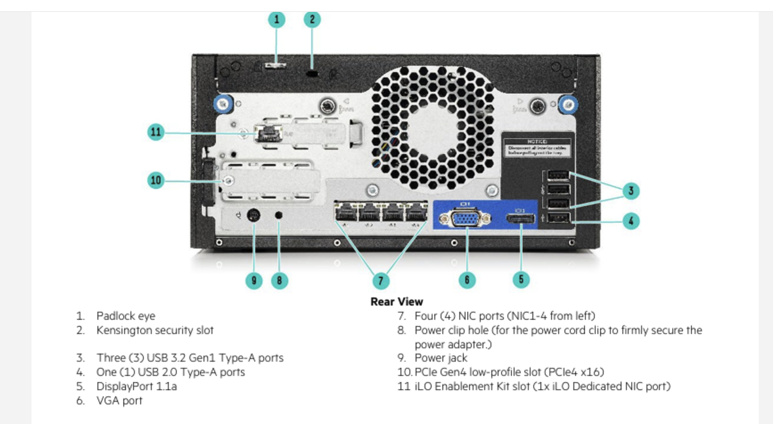

Figure HPE Microserver Gen 10 Plus V2 Rear Panel connections.

Servers are designed with network connectivity in mind and the HP Microserver Gen 10 is no exception providing 4 x 1Gb RJ45 ethernet connections, a total of 6 USB Type A connectors, and two expansion card slots 1 dedicated for the iLO enablement card and one for a range of expansion cards such as high-speed (2.5 Gb or 10 Gb), a hardware RAID card or a graphics card. Also, with an eye towards NIST compliance, the case has a locking front faceplate to limit access to the drive bays and a padlock hasp on the rear to secure the case. These features add tamper resistance to the unit improving its security and compliance with NIST.

## Firewall / Router

The Netgate SG 2100 firewall and router was selected for its price/performance trade-off, small size, and features. The device selected could have just as easily been any of a number of alternate choices including the Sophos XG86 or XGS88. It came down to a choice based on money. The Netgate 2100 at $369.00 is less expensive than the Sophos ($521.45) and several others initially but is also less expensive in the long run. This savings comes from the licensing and support costs. For example, the Sophos XGS costs $1,773.18 for the hardware and a 5-year subscription to the Sophos XStream software. The Netgate products use the open source pfSense+ software which is free for the life of the product. Netgate Support is priced at: Free (software updates and initial setup), $399/year (with 24 hour response) or $799/year (adds 4 hour response and telephone support). Pricing for Sophos is more difficult to assess as their annual costs consist of license fees for multiple products plus support fees.

From a set-up and configuration perspective the Netgate is more user friendly than Sophos albeit at the cost of a centralized (web based) management system geared towards enterprise systems. Either of the two appliances will perform admirably and the choice of the Netgate could have easily gone the other way should the VSB have multiple offices, a high number of VPN clients etc.

One advantage of the Netgate appliance and its pfSense software is the ability to install various add-on packages from a software store built into the GUI to address specific needs. For example, the Suricata open-source intrusion prevention system (IPS) is easily added to the device with free (rules are delayed by up to 30 days) or paid (rules are immediately available upon release) levels.

## Network Switch

The choice of the Netgear GS316EP network switch was driven by its rich feature set, robust all metal construction, 32Gb/sec thruput, and 16 Power over Ethernet (PoE) ports. The PoE capability makes installation of surveillance cameras or other devices much easier as no additional power adapter is required. From a pricing standpoint the $279.00 price is very affordable for a managed switch.

The GS316EP has a SFP port to connect with the router plus 15 additional PoE (RJ-45) connections for network devices. The browser-based management interface allows the administrator to assign ports to a Virtual LAN (VLAN), impose Quality of Service limitations, port mirroring, and port aggregation to increase thruput to selected devices. Many of these feature fall into the ‘nice to have’ category but are useful for growth or expansion.

1. Designing a Representative Level 1 Lab Network

Once the secure workstation and single-person company needs have been met, the next task is combining two or more of the workstations with other supporting equipment and software to form a low-cost, cybersecure, Level 1 Network.

The below diagram is a notional representation of a core network for a Very Small Business (VSB) that the author created to test various software and network settings to achieve baseline compliance with the FAR 52.204-21 / NIST 800-171 Low requirements. With minor modifications, it could easily expand to provide additional capabilities, add users, and become NIST 800-171 Moderate (Level 2) compliant.

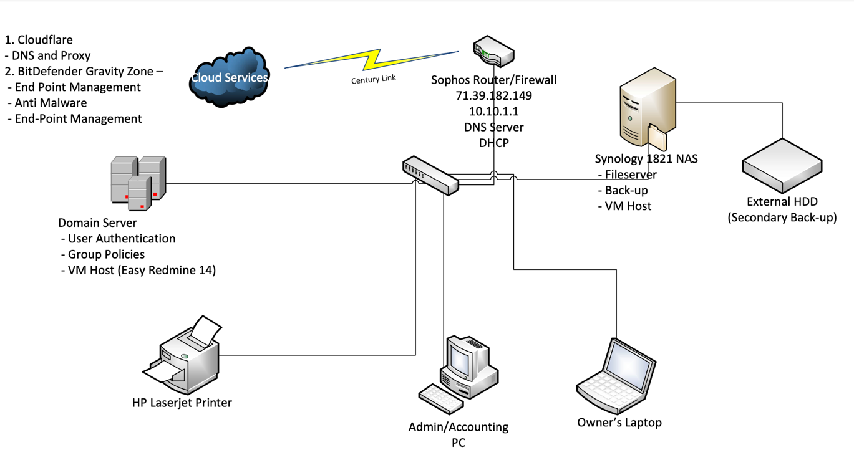

Figure Notional VSB Network Layout

### Network architecture and design considerations

The below considerations are based on a variety of source information and personal experience with a laboratory system over the past 4 years. The overall design is based on the needs of the typical very small business as described in Chapter 1 one of this paper.

The lab network is based on a wired network approach since all the equipment is located in a small area. Additionally, wired connections are perceived as being slightly more secure and with a potential speed advantage over all but the newest WiFi 6 equipment. While some experts say things like “modern Wi-Fi is now firmly positioned as a genuine alternative to an Ethernet connection for both consumers and businesses with a wealth of devices now at their disposal.”[81] Although the newest Wi-Fi 6 holds a slight advantage over the standard 1GB/sec ethernet, newer wired technologies are also available providing 2.5, 5, and 10GB/sec transfer rates easily trumping Wi-Fi technologies while still providing the security of a point-to-point wired as opposed to radio) connection. When designing the network the type of work likely to be performed, the size of files created, and the number of users all pointed to the conclusion that a high-speed network (i.e., faster than the ‘standard’ 1Gb ethernet) was likely unnecessary and would add expense with little payoff.

True, encrypted Wi-Fi is reasonably secure but it’s hard to dismiss the security advantage offered by a wired approach that requires physical access (or VPN) to the network for a connection.

### Firewall/Router

A hardware router/firewall should stand at the entry to the network as the gatekeeper. The router assigns incoming traffic to a particular network address, filters content, and applies various rules to correctly route incoming and outgoing traffic. The firewall function serves to block malicious content. While most computers attached to the network will have some level of a software firewall enabled, the network firewall is the doorman keeping the riff-raff outside and is the ultimate decider of what gets in or what gets out of the network.

The recommended network configuration features a more configurable and robust hardware router and firewall than typically provided by internet service providers. The standard (consumer) device typically meets or exceeds the needs of a homeowner but falls short of the robust capabilities of a commercial or business-oriented device. PC Magazine reports[82] :

“What you will get in business-class routers at all price points is stronger security features, more flexibility in giving you access to your network from remote locations, and the ability to scale as your business grows.”

Here are some of the features typical of the business class devices:

* Robust VPN for multiple users
* SSL Portal and SSL Tunnel VPNs
* Virtual Networks (VLANS) to segment the network into separate enclaves thus allowing sensitive information to be compartmentalized.
* IPv6 Support for expanded network addressing
* DMZ port for webserver or other device that needs direct internet access
* Content Filtering: the ability to block access to certain Internet content by using keywords or blacklists (prohibited URLs), or by allowing clients to access only permitted sites through a whitelist.
* Stateful Packet Inspection: [83] “*a dynamic packet filtering technique for firewalls that, in contrast to static filtering techniques, includes the state of a data connection in the inspection of packets.”*
* [**Endpoint detection and response**](https://www.fortinet.com/products/endpoint-security/fortiedr) [84] (EDR) can detect and block threats on your organizations endpoints and offer a variety of response options. It can analyze the nature of the threat and give your security team information regarding how it was initiated, where it has traveled to, what it is currently doing, and how to eliminate the attack altogether.

This combined set of security upgrades is typically provided in a hardware-based device (sometimes called a security appliance) or “Next Generation Firewalls” and combine a hardware device with proprietary software. A review of the products in this category is available from recognized industry expert Gartner at <https://www.gartner.com/reviews/market/network-firewalls> and shows a number of very similarly rated products available from recognized names like Cisco, Sophos, and SonicWall among others.

Those on a strict budget may find free or very reasonably priced open source alternatives such as those offered by pfSense which can replace the software in a consumer grade device with a more capable version or offers a very low priced NetGate appliance based on the free pfSense software (see <https://www.pfsense.org/products/>). In very small organizations the firewall/router software can run on an old or obsolete PC, as a virtual machine on an existing server, or on another network device such as a Synology NAS device.

### Switches

Wired networks require a separate cable connection for each network device (also called an endpoint) as shown in Figure 7 (above). These connections are typically made using cables that meet certain industry standards often referred to as Cat5, Cat 6, etc. and connect with a slightly larger version of the connectors commonly used on telephones called an RJ-45. Stringing and terminating cable is a chore best left for technicians but once all the wired runs have been made (using pre-manufactured cables or custom on-site wiring) they need to be connected to the network – and that’s where the switch comes in.

Switches come in a variety of sizes (usually classed by the number of ports or connections available) speed or bandwidth (typically ranging from 1 gigabyte per second to 10 gigabytes per second) with older (slower) technologies still in use in some instances, and their ability to manage traffic. Connection types are typically wired (RJ-45) connections on standard 1Gbps devices with fiber optic connections being prevalent on higher speed (10Mbps) devices. Some switches feature a single fiber optic ‘uplink’ to a high-speed device and then apportion that bandwidth to multiple 1Gbps devices to improve overall performance.

This then leads into the second differentiating feature of switches i.e., is the device managed or unmanaged. This distinction means that the switch can use rules to control the network traffic it passes and can assign priority to certain devices to balance network performance and load. Such devices are typically not needed in VSB networks but may be added as the business grows.

Managed switches, while more expensive than their unmanaged brothers, do offer certain added feature sets that make them attractive in corporate environments including quality of service (QAS), additional security and monitoring features, and the ability to remotely manage the network. Most of these features are unnecessary in a 10 to 20 endpoint environment as found in a VSB so their extra expense is usually a dealbreaker.

### Domain Controller

As discussed above, the Management of the network is performed by the domain controller (DC). It can be one or more physical devices like a server, a virtual device that provides a set of services, a cloud-based function or some these. It’s probably easier to think of the DC as a function rather than a discrete device since the services of the DC could be apportioned to more than one physical piece of hardware.

What’s import is that when the network grows to a state where there are multiple devices and multiple users some management device is needed to perform the following functions including basic services:

* User authentication – assigning and checking credentials for users and the management of user groups.
* Domain address management using tools such as Dynamic Host Configuration Protocol (DHCP)
* Cryptological services such as device (disk) encryption, communications security via Transport Layer Security (TLS), and maintaining a secure archive of encryption keys such as for Payment Card Industry (PCI) Data Security Standard (DSS).
* Translation of human readable addresses (xyz.com) into their Internet Protocol (IP) addresses using Domain Naming Service (DNS)
* Rights management – assigning and enforcing user roles, access rights to network devices or services, and privileges (authorization for restricted or potentially harmful functions)
* Directory services – maintaining a list of files and directories on the network and enforcing access controls on them
* Network policy definition and enforcement to implement network security practices

The implementation strategy has been a difficult journey to define as there are a wide variety of possible solutions and price points that drive the decision. Consequently, the architecture of a compliant DC is going to be an ‘it depends’ situation driven by the VSB size, budget, individual preferences, and most importantly the level of cybersecurity compliance required i.e., Level 1 comprising FAR 52.204-21 and or CMMC Level 1 or Level 2 CMMC with or without third party assessment.

### Option 1 – Synology NAS

As presently delivered, the Synology NAS lacks a hardware-based encryption module compliant with FIPS 140-2 and a published STIG making it a potential for a Level 1 DC but with some compliance risks. For use outside of Government Contracting the Synology NAS is an excellent and cost-effective choice providing all the necessary services (albeit some are duplicative of those offered in a commercial firewall forcing a choice between the two) along with a robust and captious (SHA 256 encrypted) storage capability for backups. The device even offers an ability to host virtual devices or containers permitting the low cost hosting of any number of Widows or Linux applications. As stated earlier the major constraint is the lack of FIPS compliance thus limiting its applicability to non-NIST 800-173 uses.

### Option 2 – Linux Server

The better solution would be a low-cost server such as a HP MicroServer Gen 11 running a Linux distribution such as Rocky Linux 9 (RL9) which is a free distribution derived from the Red Hat Linux (RHL) product and compatible with all the RHL tools such as OpenScap.

From a cost perspective the Microserver Gen 11 and the Synology DS 1821+ are competitive albeit the Microserver is limited to the number of storage devices whereas the Synology starts with more (8 vs 4) and has expansion modules readily available.

The major difference however is the Synology is designed for a specific purpose (network attached file storage) and comes with a suite of software and tools specific to that purpose and the HP Microserver Gen 11 (older Gen 10 or Gen 10+ devices are also acceptable) is built from the ground up to be a network server offering such capabilities as Integrated Lights Out Management (iLO 5) for remote management, a server grade BIOS with additional security features etc.

While there are any number of devices that could fill this role, the HP MicroServer Gen 11 was selected based on low cost[85], small form factor, quiet operation, and server-grade feature set.

In development work for the Level 1 Workstations the RL9 distribution was installed with all FIPS 140 encryption algorithms and other security requirements met in a 100 percent compliant manner. Using it as a base for the server is a low cost and effective choice. When paired with the HP MicroServer the four available drive bays would sufficient capacity to establish a RAID for network storage and backup. The existence of 4x1Gb Ethernet ports, iLO, and available expansion slots add to the utility of this device as the hub of an effective VSB network.

Consideration must also be given to scaling the solution for growth from a Level 1 to a Level 2 when needed. Consequently, the CyberHygiene Project DC selection was made to use the HP Microserver Gen 11 for entry level requirements based on Level 1 compliance with the capability to easily migrate to a more capable Level 2 system as the business grows.

## The Essential Nature of Third-Party Service Providers

Despite the many advances in automation and AI, the truth of the matter is almost every VSB will need outside assistance to implement and maintain a cybersecure environment. The key question is ‘How much outside assistance will be required and what will that cost?”

### Endpoint Management Software/Services

En point management products like those available from Sophos or BitDefender are often used by managed service providers or environments with a dedicated IT department to not only monitor the antimalware installed on network assets but to also establish and enforce secure configurations of the attached systems and manage the installation of software updates (patches) as they are released.

Establishing a secure (hardened) network environment is important – but keeping that environment secure over time as new threats emerge is essential!

Thus, endpoint management is essential to not only secure the network initially, but to keep it secure as new threats emerge. Several products are available including Microsoft’s intune, Atera, Cisco Secure Endpoints, Sophos, Crowdstrike, ManageEngine, and the afore mentioned BitDefender.

Any of these endpoint management products combined with an antimalware product (most are usually bundled as a package) will provide oversight for a small business network. The real question then becomes a matter of who is responsible for monitoring and acting on the data collected and reported by the software – the business owner, an employee, or a third party ‘managed service provider’ (MSP).

In many – if not most small businesses – this role will be fulfilled by a MSP. The typical solution is the MSP offers a package of software and services including endpoint management, network monitoring (reported intrusions, incidents, malware etc.) patch management, remediation, and ‘break-fix’ support at defined cost per user.

The proposed system bypasses this solution and self-installs and monitors the end-point management process. Others may choose to source this with a MSP but in doing so they should expect to pay a monthly fee per user plus (in some cases) an initial set-up cost.

### BitDefender Gravity Zone

The BitDefender Gravity Zone (GZ) endpoint management software is a Swiss Army knife in the CyberHygiene Project. Although it is a paid product it offers some true value for the cost. GZ is a combination of the BitDefender anti-malware product plus end-point management capabilities, patch management, and full disk encryption. This product secures each endpoint in the network against threats that either originate within the network or come from an outside source using both an Endpoint Detection and Response (EDR) solution and an Extended Detection and Response (XDR) approach.

“GravityZone EDR is the only EDR on the market providing automatic correlation of attacks across endpoints. By automatically consolidating incidents to a unified larger incident, it accelerates response and streamlines workflows.”[86]

GZ not only scans and neutralizes malware – be they viruses, trojans, or ransomware – at an amazing 100 percent effectiveness in comparative testing, it also monitors and reports system security compliance. GZ looks for system misconfigurations and can actually remediate them.

This is a significant benefit for Windows based systems and obviates the need for tother products such as Senteon.

GZ is effective with other OSs including Linux and Mac OS but it’s primary benefits come when Windows devices are addes to the network. The compliance feature makes GZ a standout in a crowded field and earned it a place in the CyberHygiene Project.

The endpoint management features in GZ also include detailed risk management capabilities that identify and assist with mitigation of specific vulnerabilities on network attached devices (endpoints).

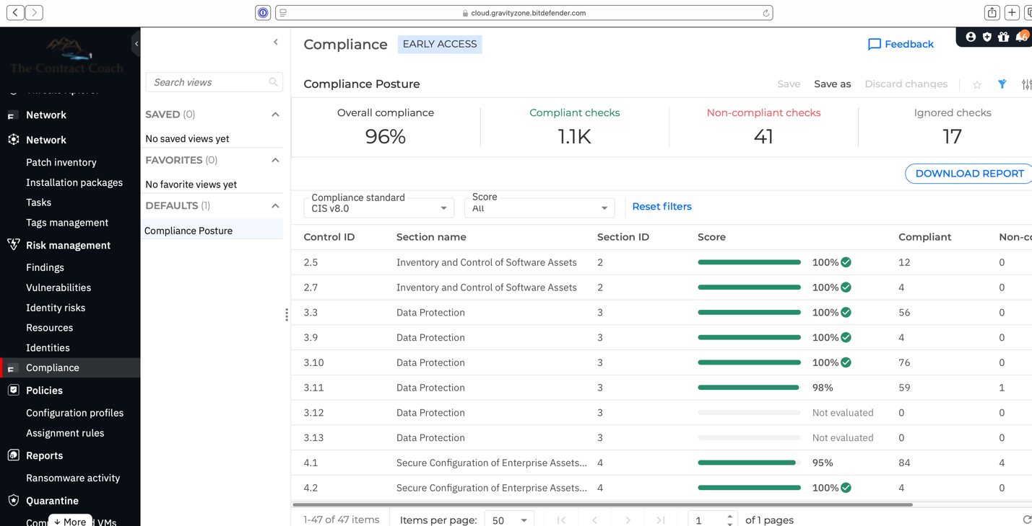

Figure GravityZone Compliance Dashboard.

GravityZone’s dashboard is web accessible via <https://cloud.gravityzone.bitdefender.com> such that the VSB owner can defer actual management of the service to a Managed Service Provider (MSP) as a part of their contracted support service agreement.

### Open VPN

Other services include Virtual Private Network (VPN) services provided by Open VPN (a free VPN system) to allow secure remote connections to the network through an encrypted point to point connection. Open VPM leverages the existing OpenSSL service to create secured connections using FIPS 140-3 via OpenSSL 3.0.12+, and the FIPS Object Module 2.0. Client connections automatically enforce FIPS crypto via their host settings.

### Cloudflare

Cloudflare offers a free version of their product including VPN and DNS services for very small businesses that adds several important features to enhance security. The first is Cloudflare operates one of the premiere Domain Naming Services (DNS) located proximately at an IP address of 1.1.1.1. The free service allows users to relocate their DNS records from their hosting provider (like goDaddy etc.) onto Cloudflare making domain name translation from a name to an IP address near instantaneous.

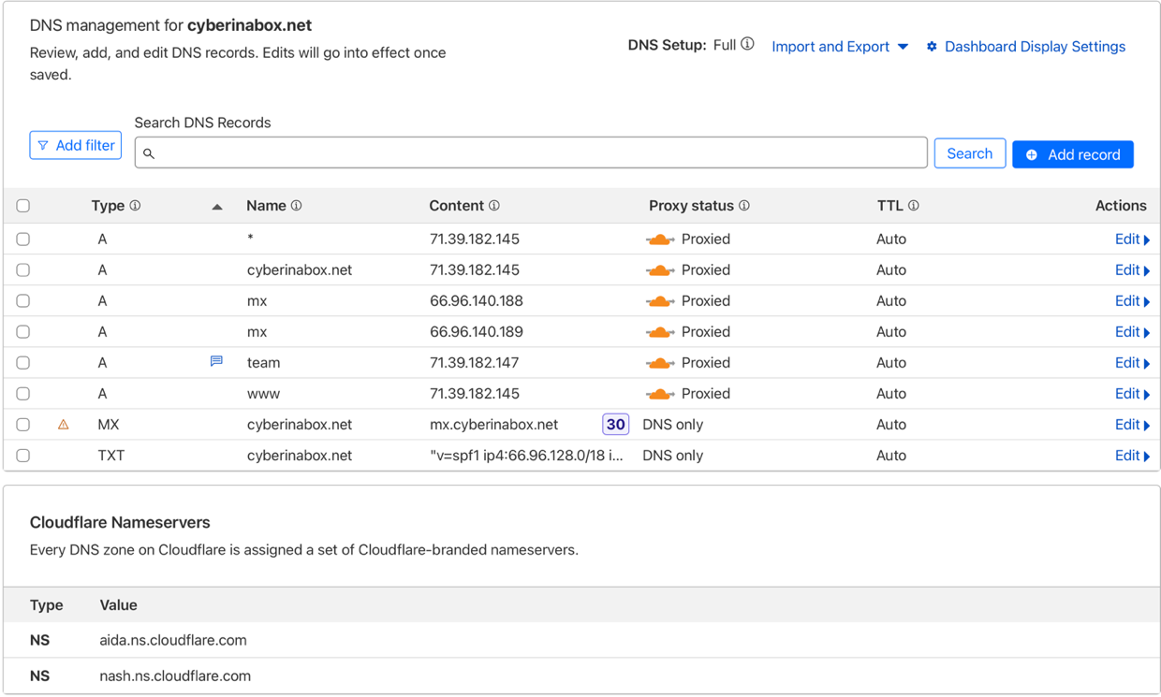

Figure Cloudflare DNS Record

Cloudflare also provides an array of informational reports concerning traffic and bandwidth consumed as shown below.

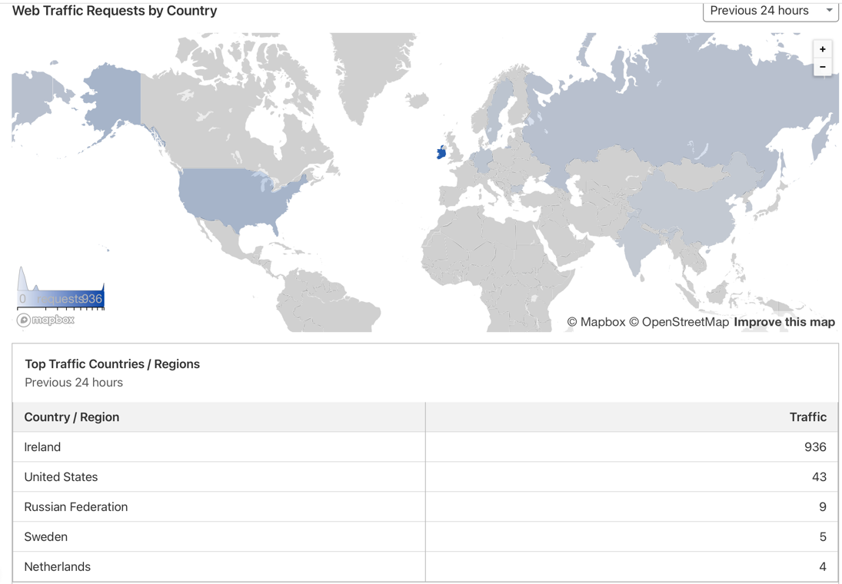

Figure , Cloudflare Traffic Analysis Report

The service also provides detailed logging of wide area network (WAN) traffic and how (or if) the traffic was routed. Cloudflare also provides a defense mechanism against Dedicated Denial of Service (DDS) attacks which try to overwhelm serves with massive amounts of incoming traffic.

Cloudflare also supports secure DNS lookups over TLS or HTTPS making it near impossible for a ‘man-in-the-middle’ to monitor DNS requests.

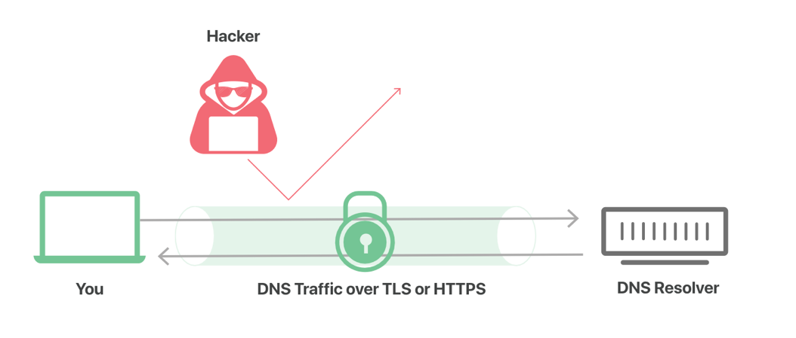

Figure Secure DNS SeRvice Prevents 'Man in the Middle' Inspection

The secure lookup is provided via a free app (Warp) that creates a VPN to their DNS server thus ensuring DNS information is not shared with third parties such as governments or internet censoring programs.

### User Authentication and Multi-Factor Identification

One of the free services selected for the CyberHygiene Project system is an identiy and access management (IAM) service provided by FreeIPA installed on the

Centralizing this service offers some significant advantages including off-loading the task to another service, access available from outside the network for remote logon, and an application programming interface (API) usable by other software to verify user identities via a Single Sign On (SSO) capability. Bundled with this service is a multi-factor authentication (MFA) service using an authenticator application on a mobile phone or other device as an additional safeguard.

The combined LDAP and MFA services are essential for meeting the Access Control requirements of the cybersecurity framework in NIST SP 800-171 and others. Being able to do this at no cost (other than setting it up) is a significant benefit.

### pfSense

The NetGate firewall and router used by the CyberHygiene project is operated by pfSense software.

“a [firewall](https://en.wikipedia.org/wiki/Firewall_(computing))/[router](https://en.wikipedia.org/wiki/Residential_gateway) computer software distribution based on [FreeBSD](https://en.wikipedia.org/wiki/FreeBSD). The [open source](https://en.wikipedia.org/wiki/Open-source_software) pfSense Community Edition (CE) and pfSense Plus is installed on a physical computer or a [virtual machine](https://en.wikipedia.org/wiki/Virtual_machine) to make a dedicated firewall/router for a network.[[3]](https://en.wikipedia.org/wiki/PfSense#cite_note-3) It can be configured and upgraded through a web-based interface, and requires no knowledge of the underlying FreeBSD system to manage.[[4]](https://en.wikipedia.org/wiki/PfSense#cite_note-Infoworld-4)[[5]](https://en.wikipedia.org/wiki/PfSense#cite_note-fsm-5)” [87]

With respect to the CyberHygiene Project, the pfSense is hosted by a hardware device (NetGate 2100) that is a 1.2GHz ARM Cortex powered single-board computer dedicated to one purpose: running pfSense to route and control network traffic with the Internet provider.

In the CyberHygiene Project Lab the Internet provider (Comcast Business Systems) provides Wide Area Network (WAN) service to their own router/firewall. But, as discussed above, their consumer grade device is supplanted with the NetGate device to improve security.

pfSense, as a modern Linux product/distribution, offers a software store built into the app allowing the administrator to select ‘packages’ of open source software that can be added to expand the functionality of the device.

### Suricata

Many of the features in GZ are also available in Suricata which installs as an optional package in the pfSense app on the NetGate 2100 firewall/router. Suricata is an open source (free) intrusion detection system (IDS) and intrusion prevention system (IPS). Suricata provides traffic filtering and monitoring using a rules based approach to detect common attack vectors such as port scanning, denial of service, and brute force attacks.

Suricata monitors and logs HTTP and DNS queries and responses and provides logging and analysis of TLS/SSL transactions. Its rule set either allows the connection to occur and logs it or, if covered by a rule, blocks or rejects the connection and logs that. Suricata also interacts with other network monitoring software to provide detailed network traffic analysis dashboards by reading and interpreting Suricata’s logs.

Suricata rules are either obtained from an archive e.g., <https://github.com/daffainfo/suricata-rules> or can be user created. The GitHub archive is a community effort and is frequently updated to address new and emerging common vulnerability and Exposures (CVEs) reported or discovered by the community through association with organizations like ProjectDiscovery.[88]

### Summary of Third Party Software and Services

The above products are included as they are a component of the overall cybersecurity solution. However, from a cost point of view they are more of an IT expense than a cybersecurity expense as they are billed on a monthly or annual basis whereas Cybersecurity costs are more of a one-time investment. Once the network is up and running in a stable manner, administration is relatively simple and consists of monitoring automated alerts and ensuring appropriate software is installed.

The software stack (or suite of services) selected provides a robust and highly sophisticated set of security tools from detecting and reporting network intruders; to identifying and blocking malware, viruses, and ransomware; managing software updates and security patches; to ensuring only properly authorized and authenticated users access the network; and providing sophisticated logging and routing services in a secure environment.

Collectively these services are very low cost or outright free and are all priced well within the reach of individual users or ‘one-man bands’ like consultants - but have the power and flexibility needed to handle much larger networks as the business frows and evolves.

The above products are capable of automating periodic scans for network health and reporting anomalies. Many users with a STEM background may elect to do many of these tasks themselves and save on the MSP costs. Other businesses will avail themselves of the full set of features offered by an MSP (albeit at a higher price[89] ) in lieu of the al-la-carte support of fixing something when it breaks and possible down-time awaiting a technician to attend to their problem.

While the author has purchased and used many of these services to support their own consulting practice, not everyone will share my knowledge, ability, or interest in self-administering the resulting network. Towards that end, there are a number of MSPs who specialize in very small businesses and these tools were all selected based on an ability for a MSP to perform some or all of the network administration functions remotely. It’s primarily an issue of time, talent, and money.

1. Level 2 Authentication Upgrade

With existing workstations and servers hardened via OpenSCAP to the "Unclassified Information in Non-Governmental Facilities" profile on Rocky 9.6, you're already establishing a strong foundation that aligns well with NIST SP 800-171's system and communications protection (SC) and configuration management (CM) families. This Rocky Linux hardening profile (based on SCAP Security Guide) enforces controls like FIPS mode, firewall rules, SELinux enforcement, and secure boot—many of which directly support the identity management requirements for Level 2 compliance.

## Network Hardening Overview

The first step is to identify and correct known vulnerabilities by performing a complete scan of every endpoint on the network – including the Router, Switches, Computers (or servers) and virtual machines for an exhaustive list of possible vulnerabilities.

The list of vulnerabilities is called (among other names) a Security Technical Implementation Guide (STIG) which is “a configuration standard consisting of cybersecurity requirements for a specific product”[90] A repository of STIGs is maintained at the National Institute of Standards and Technology (NIST) at https://ncp.nist.gov/repository . An alternate source is the Center for Internet Security (CIS) who publish a series of CIS Benchmarks which are mapped (cross referenced) to the DISA STIGs and are acceptable for use for government systems (“While the use of STIGs and SRGs by CSPs is preferable, industry-standard baselines such as those provided by the Center for Internet Security (CIS) Benchmarks are an acceptable alternative to the STIGs and SRGs.”)[91]

## How Hardening Enhances Identity Management

The OpenSCAP profile addresses several IA-adjacent controls automatically, allowing you to focus on the remaining gaps from my previous response. Here's a quick mapping:

Table , Identy Management vs System Hardeneing

|  |  |  |
| --- | --- | --- |
| Hardening Aspect (OpenSCAP Profile | Relevant NIST SP 800-171 Rev 3 Control(s) | Impact on Your IA Setup |
| FIPS Cryptographic Module Enforcement (e.g., crypto-policies set to FIPS) | 3.5.7 (Cryptographic Module Authentication) | Ensures MFA (TOTP) and VPN crypto in pfSense uses validated modules. Verify pfSense's OpenSSL is FIPS-compatible or configure it via FreeBSD's crypto settings. |
| Account Management Rules (e.g., no guest accounts, password complexity via PAM) | 3.5.4 (Authenticator Management), 3.5.5 (Identifier Management) | Rocky enforces local password policies (e.g., min length 14 chars, no reuse)—sync these with pfSense User Manager rules to avoid conflicts. Automates inactivity disabling (e.g., 35-day lockout). |
| Secure Session Management (e.g., screen locks after 15 min, SSH key auth preferred) | 3.5.11 (Re-Authentication), 3.5.10 (Adaptive IA) | Supports pfSense's session timeouts by requiring endpoint re-auth, creating layered protection. Enables risk-based prompts if integrated with tools like SSSD. |
| Device/Endpoint Security (e.g., 802.1X supplicant config, MAC randomization disabled) | 3.5.2 (Device Identification and Authentication) | Prepares endpoints for certificate- or 802.1X-based auth via pfSense's RADIUS. Rocky 9.6's wpa_supplicant is hardened for this. |
| Auditing and Logging (e.g., auditd rules for auth events) | Overarching IA policy (evidence collection) | Logs local auth attempts, which correlate with pfSense's portal logs for full audit trails—key for 3.5.5 tracking. |

This hardening covers ~40-50% of the IA family's implementation burden, as the profile includes 300+ rules mapped to SP 800-171. For your 5-10 user team, it means less custom scripting and more reliance on built-in Rocky tools like `authselect` for PAM and `sssd` for centralized auth.

## Updated Gaps and Targeted Actions for Level 2 IA Compliance

Building on the previous table, here's a refined view of remaining identity management requirements, prioritized by effort for your hardened environment. Focus on integration between pfSense (network layer) and Rocky endpoints (host layer).

Table Level 1 vs Level 2 Gaps

|  |  |  |  |
| --- | --- | --- | --- |
| Control Number | Key Remaining Gap | Targeted Action with This Setup | Effort Level (for Small Team) |
| 3.5.2  Device ID/Auth | No centralized device certs or 802.1X enforcement | Configure pfSense FreeRADIUS for 802.1X;  on Rocky, enable wpa supplicant with machine certs (generate via `certmonger`).  Test with `eapol_test`. | Medium (1-2 days) |
| 3.5.4 Authenticator Mgmt | Policies for credential lifecycle (e.g., revocation procedures) | Document in your IA policy;  Use Rocky's `authconfig` to enforce complexity.  For pfSense MFA, add admin procedures for TOTP secret rotation. | Low (Policy doc + 1 hr config) |
| 3.5.5  Identifier Mgmt | Formal assignment/tracking processes; sync with HR for offboarding | Integrate pfSense User Manager with LDAP if scaling, or script Rocky `useradd` with pfSense API.  Set 90-day inactivity disable via `pam_faillock`. | Low-Medium (Script/policy) |
| 3.5.6  Auth Feedback | Captive Portal may show partial feedback | Customize pfSense portal HTML to mask fields (e.g., `type="password"` everywhere);  Rocky's login screens already obscure. | Low (30 min tweak) |
| 3.5.7  Crypto Modules | Confirm pfSense FIPS compliance | Enable FIPS in pfSense (via System > Advanced > Cryptographic); aligns with Rocky's mode.  Test with `openssl fipsinstall`. | Low (Verify + enable) |
| 3.5.8  Non-Org Users | Guest access not defined | Add pfSense voucher system for guests;  Rocky profile blocks local guests—route them via separate VLAN. | Low (If no guests needed) |
| 3.5.9  Service ID/Auth | API/script auth not covered | Use Rocky's `sssd` for Kerberos tickets; pfSense HAProxy for API cert auth. | Medium (If services exist) |
| 3.5.10  Adaptive IA | Static MFA only | Add pfSense GeoIP rules for risk-based prompts, or integrate Rocky's `fail2ban` with pfSense logs. | Medium-High (Optional enhancement) |
| 3.5.11  Re-Auth | No triggers for privilege changes | Set pfSense idle timeouts to 15 min (match Rocky screen lock);  Use sudo on Rocky for re-auth on escalation. | Low (Config sync) |

## Implementation Roadmap and Compliance Tips

1. Integration Layer: Use LDAP (e.g., FreeIPA on a Rocky server) as a bridge—pfSense authenticates against it, and Rocky joins via `realmd/sssd`. This centralizes 3.5.5 management without replacing your local setup. For 5-10 users, a single VM suffices.

2. Automation and Evidence: Run periodic OpenSCAP scans (`oscap xccdf eval`) to generate reports as IA evidence. Export pfSense configs via Diagnostics > Backup/Restore for audit snapshots.

3. Policy Development: Create a single IA Policy document covering ODPs (e.g., "90-day inactivity period"). Reference your OpenSCAP profile as baseline compliance for host-level controls.

4. Testing for Level 2: Simulate scenarios like device spoofing or user termination. Use tools like `nmap` for 802.1X tests and review unified logs (pfSense + Rocky's journalctl).

5. Scalability Note: Your hardening ensures endpoints stay compliant during updates (Rocky 9.6 STIGs auto-apply via `dnf` plugins), so focus pfSense on network enforcement.

This positions you for efficient Level 2 attainment—your OpenSCAP work likely satisfies 20+ non-IA controls too. If you share OpenSCAP scan results or details on services/APIs in use, I can pinpoint exact configs.

1. Rocky Linux Installation and Configuration

This is the ‘secret sauce’ of the entire project. I’ll run through it at a top level and will make my installation notebook available for others on a ‘by request’ basis. Interested parties may find the video at <https://www.youtube.com/watch?v=iHWVAYsG6Jk> helpful as an overview, but be aware there are a couple of inaccuracies and omitted steps here so it will get you close … but not 100%! My approach, on the other hand, will get you 100% the first time.

## Installing Rocky Linux 9.6

Rocky Linux is freely available for download at <https://rockylinux.org/download> . Some care must be exercised as there are multiple versions and options. I suggest rocky-9.6-aarch64-dvd.iso for most use cases. This is the version for the Intel X86 family of processors. The dvd version simply means that it contains additional packages (a term you become familiar with in Linux) that allow installation from the downloaded .iso file as opposed to having to visit various sites to find add-ons.

The downloaded image will be saved to your local computer and will be about 2.6 GB in size. This image will then be used to create a USB boot media on a suitable usb drive by using an appropriate utility. Personally, I downloaded to my Mac and used the diskutility to make the copy. For the techies here’s the commands:

* Unmount the target disk with: *diskutil unmountDisk /dev/diskX* (replace X with your disk number)
* Run *sudo dd if=/path/to/your.iso of=/dev/rdiskX bs=1m* to copy the ISO to the USB drive.
* Wait for the process to complete – it may take 15 – 20 minutes or more.

With the newly made boot USB drive in hand the fun begins! The target computer is powered on and the start-up process is interrupted by pressing a specific key as soon as a logo appears. For HP computers that will be the ESC key. For Dell Laptops it will likely be the F2 key. Make sure the USB is plugged in before starting.

The next step is to use the BIOS on the targeted computer to select booting from the USB drive then exiting the set-up program. That will start the installation process using the GRUB bootloader.

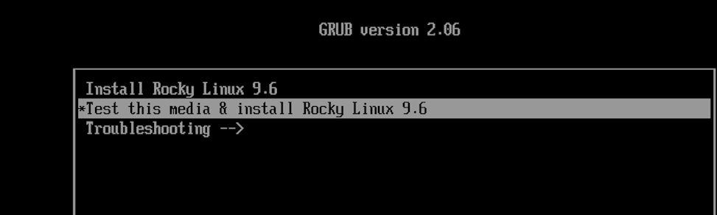

***If there is a secret to creating a secure installation – this is it!***

***Press the up arrow key to highlight “Install Rocky Linux 9.6” and then type the letter ‘e’ for edit. This feature is somewhat obscure so it took a while to find it!***

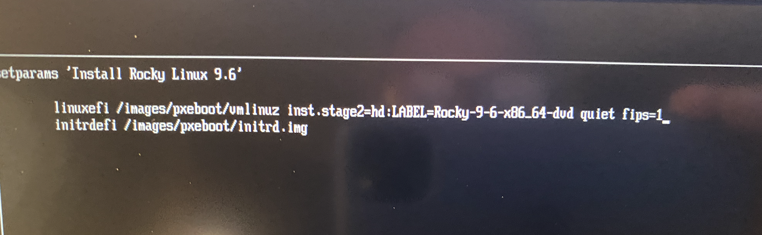

Figure , GRUB Bootloader edits to impliment FIPS.

When you hit ‘e’ you will see this screen. Look carefully at the first indented line (‘linuxef1 /images/ ….). Use the up/down and left/right arrows to move the cursor to the end of that line and then

type a space,

type fips=1

Press the TAB key to signal you have edited the text and

Press Control + x (hold the control key and type x) and the installation will begin! This step is essential to override the default Linux encryption and force it to use the government’s approved FIPS-140-2 or -3 encryption.

The installer will ask for language preference next and then take you to the Intallation Menu

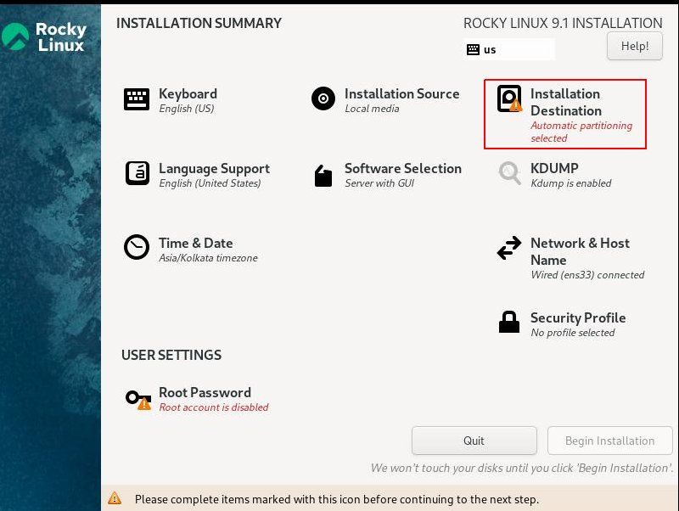

Figure Rocky Linux Installation Menue

Most of this is standard like what keyboard do you use, what time zone are you in and so forth so I’ll assume that’s not going to be of concern. But I will advise you to be cautious when creating a user account because if you forget to check the box to make yourself an administrator you will have to start over.

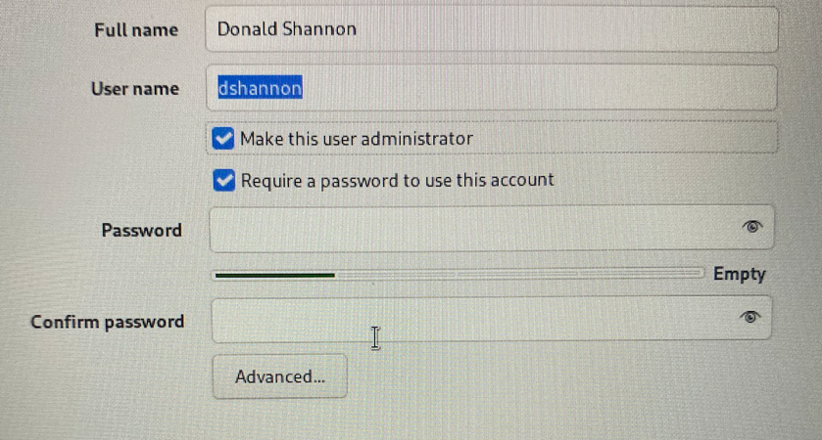

Figure Add User Dialog

Under the Software selection I recommend selecting Workstation as opposed to Server. Here’s my choices … yours can differ.

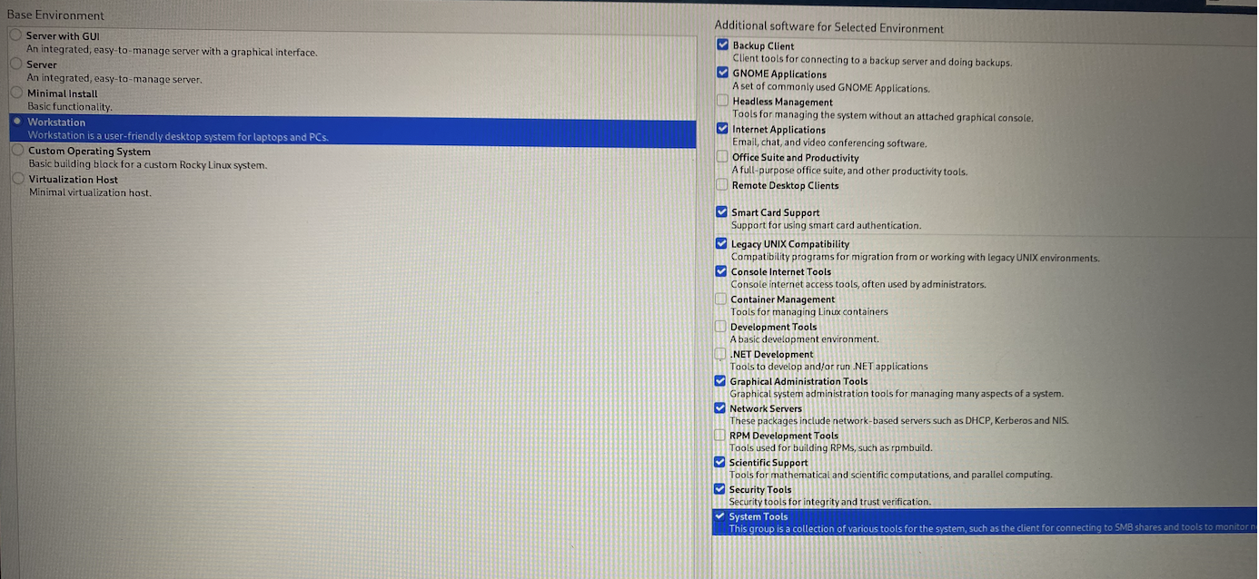

Figure , Optional software selection based on Computer role

The Installation Destination is a second part of the secret sauce.

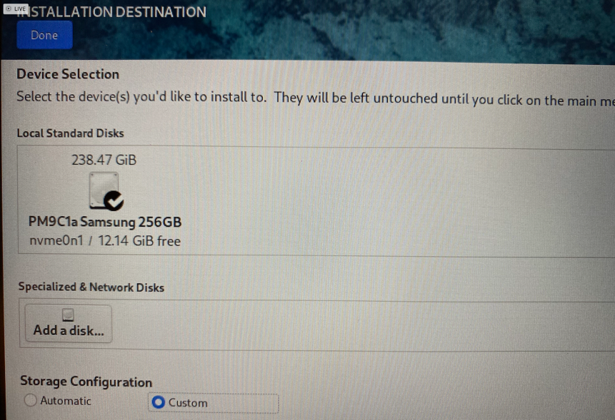

Figure , Selecting the Installation drive

You must ensure the installation disk is checked and you must select CUSTOM for the storage configuration. This is something I struggled with for several weeks on various distributions of Linux before ‘breaking the code’ so pay attention to the following:

To meet NIST SP 800-171 requirements the disk must be divided into several “partitions” so as to segregate key data and operating system files. This is very technical but here’s an overview:

First it’s easiest (but not essential) to start with a blank disk. If your disk has an operating system installed I prefer to replace it rather than doing a dual boot set-up.

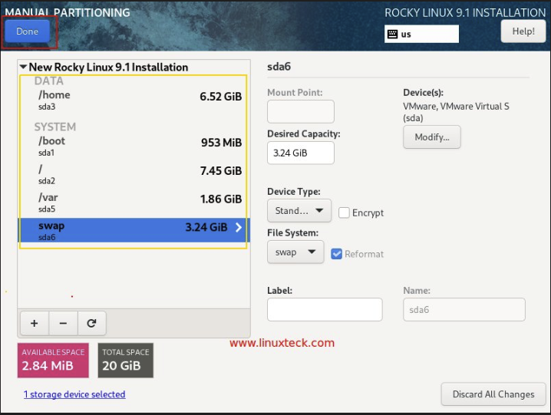

Figure Manual Partitioning of the Installation Drive

When you select the manual mode you will be shown a screen like this listing the existing disk partitions.

WARNING

*The following procedure will irretrievably erase and reformat your disk. You WILL lose all data stored on it. You should back-up everything on the disk to a secure backup volume unless you are willing to lose it forever.*

Moving on … select each of the listed partitions (e.g., /home) by clicking on it and then clicking on (or typing) the minus sign to eliminate that partition. Confirm your choice and proceed to the next partition until all have been eliminated. There may be an ISO9600 partition listed that cannot be eliminated. That’s normal.

Once the existing partitions have been eliminated you can create the new partition scheme.

Table Disk Partitioning Scheme

|  |  |  |
| --- | --- | --- |
| Mount Point | Encrypted | Size (250 GB Drive) |
| / | No | 80 GB |
| /boot | No | 10 GB |
| /boot/efi | No | 1 GB |
| /home | Yes | 100 GB |
| /tmp | Yes | 6 GB |
| /svr/tmp | Yes | 4 GB |
| swap | Yes | 16 GB |
| /var | Yes | 16 GB |
| /var/log | Yes | 8 GB |
| /var/log/audit | Yes | 6 GB |
|  | Total | 247 GB |

To add a partition click on the plus key in the lower left. This will give you a selection/data entry as below:

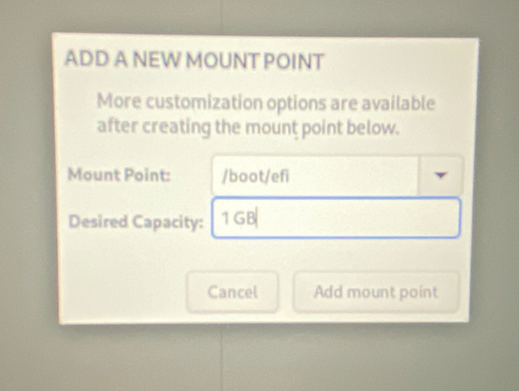

Many, but not all of the needed partitions are available via the drop down box. If one is not listed (i.e., /svr/tmp) type it in being sure to include the leading “/” character *FOR EVERYTHING EXCEPT SWAP.* The desired capacity is manually keyed in with a space separating the number and the unit (GB).

When all the partitions have been created, you must identify which partitions to encrypt.

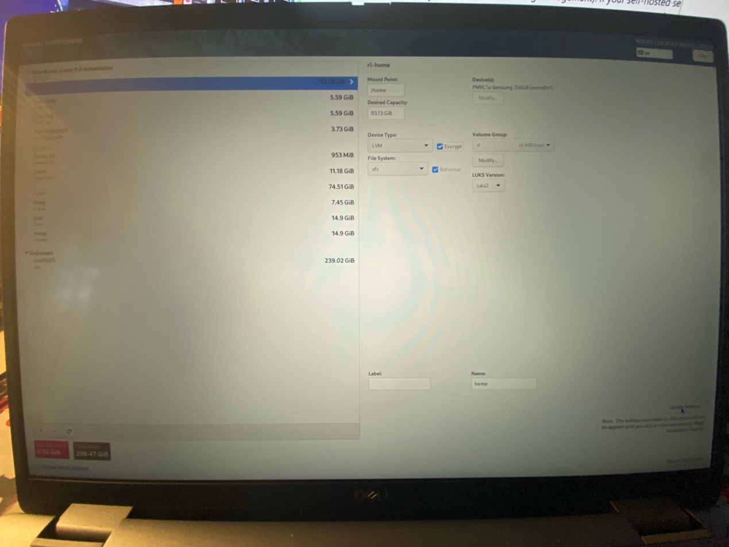



Select (click on) each partition in turn, and for those to be encrypted check the Encrypt Box and then click update settings (arrow) to record your choice. Click DONE (upper left corner) and you will be asked to confirm your choices:



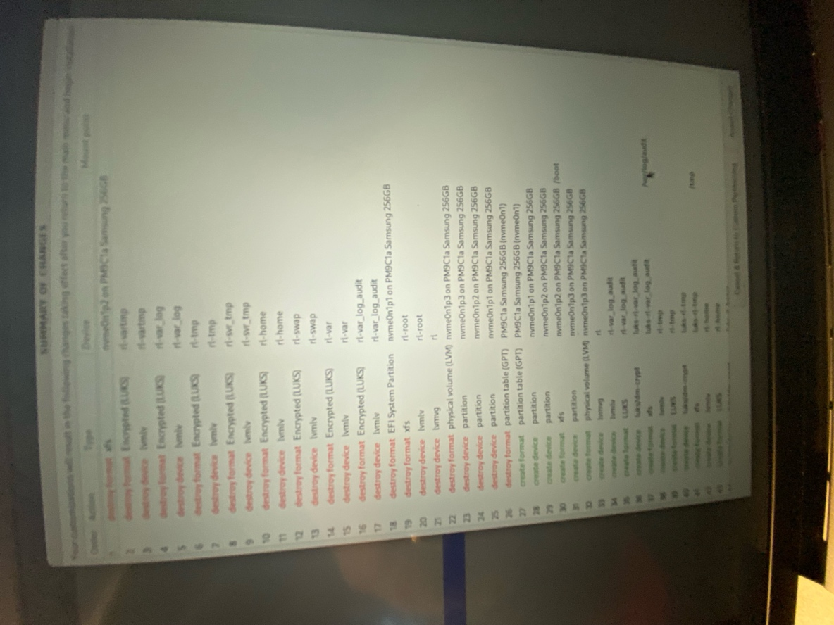

Next you will be prompted for an encryption passphrase. Be sure to use a complex passphrase for security.

Accept the accept the passphrase and return to the main screen.



Next step is Network & Host Name. If using a WiFi Connection select the appropriate network and enter the network password.

Finally, we come to Security Profile. This is very important to get right. For this installation we will be using the DRAFT Unclassified Information in Non-Federal Information Systems and Organizations (NIST 800-171).

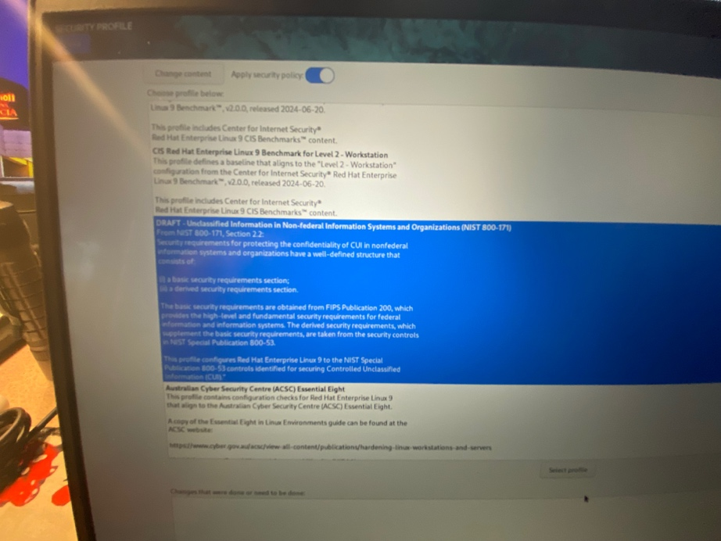

Avoid the temptation to use the DISA profiles offered as they will assume you are working in a federal facility or connected to a government information system and will impose added controls that are not needed and may create issues (like connecting to the internet).

Click done.

A checklist will appear identifying the prerequisites for this security profile and if your previous choices are aligned with the selected profile. There should be no red text warning in this list if everything was done correctly.

Back to the main screen and the “Begin Installation” button should be illuminated. If not go to the Kdump selection and disable the Kernal Dump feature and return.

You should be able to begin the installation.



Following installation, the system will prompt for a reboot. I’m not sure if this is fact or myth but here’s what I do:

1. Press enter to start the reboot.
2. Wait for the manufacturer’s logo to appear
3. Unplug the USB drive and allow the system to boot.

If all goes well, you will be greeted by a data entry field on a blank screen with the padlock symbol. This is a prompt for the encryption passphrase. Once entered the system will resume boot and present you with the log-in screen.

## Post Installation

To complete the configuration process a couple of simple tasks must be done from Terminal.

In a new terminal window enter the following command “sudo grub2-setpassword” and enter. You should see the below:

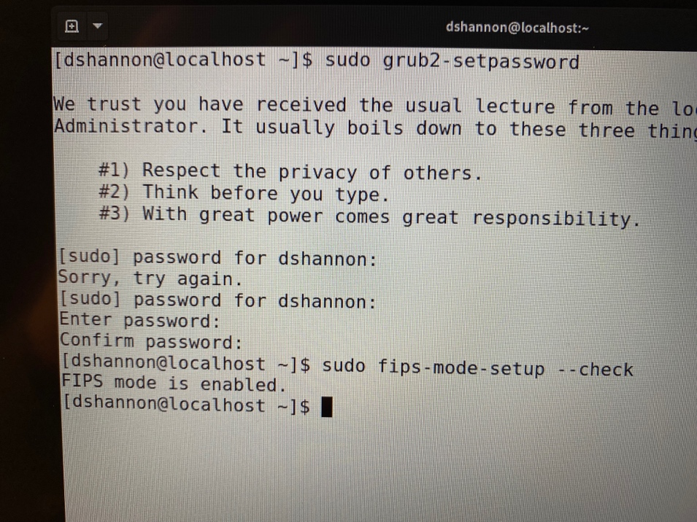

You will need to enter the superuser password to use the sudo (superuser do) command … this will be your administrator password. Next you will be prompted to enter password”. This will be your grub2 (boot loader) password. Use a complex password, enter a second time, and you should be returned to the terminal prompt [yourname@hostname]$.

Next. Enter “sudo yum install scap-workbench” and press enter. This will start an installation process for the security guide (STIG) and security evaluation program (SCAP). You will be asked to confirm a number of choices by entering “Y” for yes. Accept them all. Wait for the process to finish – it could take a few minutes.

When you receive the terminal prompt ($) again you are done and can close Terminal.

1. Performing a Client Level 1 (Foundational) Cyber Assessment

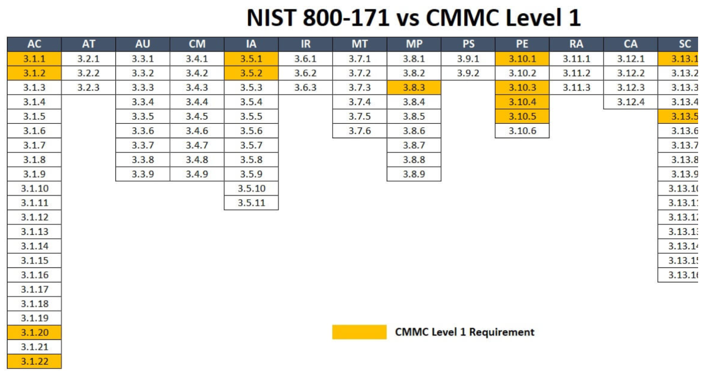

Figure , Summary of NIST SP 800-171 Controls Applicable to Level 1(Foundational)

1. Building Out the Level 1 Network: Going Beyond the Solopreneur



1. Domain Controller (Identity and Access Management

## Primary Recommendation:

1. FreeIPA (also known as IPA - Identity, Policy, Audit)  
   Why: FreeIPA provides centralized authentication, authorization, and account management via LDAP, Kerberos, and DNS integration. It's designed for Linux environments like yours, supports multi-factor authentication (MFA), role-based access control (RBAC), and auditing—key for CMMC controls like AC.2.007 (least privilege) and AU.2.041 (audit logs). It can manage your Rocky Linux workstations seamlessly with SSSD (System Security Services Daemon) for client integration. Unlike Samba, it's native to Red Hat ecosystems and avoids Windows AD emulation complexities for an all-Linux setup.   
   Alternatives to Consider: - Samba (if you need Windows compatibility later): Acts as an Active Directory-compatible DC but requires more configuration for full CMMC alignment. - OpenLDAP (with SSSD): Simpler for basic directory services, but lacks FreeIPA's built-in policy and audit tools.
2. Mail Server  
   Primary Recommendation: Postfix (SMTP) + Dovecot (IMAP/POP3) + Roundcube (Webmail Interface)  
   Why: This stack is lightweight, secure, and standard for self-hosted email on RHEL-based distros. Postfix handles outgoing mail with strong TLS support; Dovecot manages incoming mail with encryption and authentication; Roundcube provides a user-friendly web interface. Add-ons like SpamAssassin (for spam filtering), ClamAV (for antivirus scanning), and Rspamd (for advanced anti-spam/DKIM/SPF) enhance security. It supports end-to-end encryption, MFA, and logging, aligning with CMMC controls like SC.2.178 (encrypt transmissions) and SI.2.216 (malware scanning). For a small company, this avoids the overhead of full suites like Zimbra.   
   Alternatives to Consider: - Exim (instead of Postfix): More flexible for complex routing but less straightforward to secure. - Mail-in-a-Box or Modoboa: All-in-one bundles, but they might introduce unnecessary components; use if you prefer easier initial setup.   
   3. Secure File Sharing -   
   Primary Recommendation: Nextcloud  
   Why: Nextcloud offers secure file storage, sharing, and collaboration with features like end-to-end encryption, access controls, versioning, and audit logging. It integrates well with OnlyOffice (which you already have on workstations) for document editing. For CMMC, it supports FIPS-compliant encryption (via server-side and client-side options), MFA, and compliance-friendly features like data retention policies. It's self-hosted, scalable for small teams, and can use Rocky Linux's built-in Apache/Nginx + MariaDB/PostgreSQL for the backend. Focus on enabling HTTPS with strong ciphers and integrating with your domain controller for auth. - Alternatives to Consider:   
   - Seafile: Faster for large files and emphasizes encryption, but has a less feature-rich interface than Nextcloud.   
   - ownCloud: Similar to Nextcloud (it's a fork), but Nextcloud has better community momentum and security updates.
3. Integration and Security Overlaps  
   Use Apache or Nginx as the web server for any web-facing components (e.g., Roundcube, Nextcloud), with SELinux enforced and firewalld for network controls. Integrate everything with FreeIPA for unified auth to minimize credentials sprawl. Enable full-disk encryption (LUKS with FIPS) and regular backups with tools like Borg or Rsync.   
   Test compliance early with OpenSCAP scans tailored to STIGs for these apps. –
4. Why These First? They are battle-tested on Rocky Linux, have low resource needs for your scale, and allow straightforward hardening to meet CMMC Level 2 (e.g., via configuration files for encryption and access logs). Avoid proprietary or cloud-dependent options to keep it fully self-hosted. –
5. Next Steps: Once you confirm which apps you'd like to prioritize (or if you have preferences), we can dive into installation (e.g., via DNF/YUM), configuration details (like enabling FIPS mode, TLS certs from Let's Encrypt, and integration scripts), and post-setup SCAP validation. Let me know your thoughts or if you'd like to adjust based on specific needs!

System Security Plan (SSP)

<Company Name>   
<Company Address>  
<Point of Contact>, <email>, <Telephone>

# Overview

This SSP will document how **<Company Name >,** a sole proprietor, safeguards FCI per FAR 52.204-21. The covered system has been hardened using the OpenSCAP “*Unclassified Information in Non-federal Systems*” profile (xccdf_org.ssgproject.content_profile_cui) and CIS Level 2 benchmarks. Those checks are designed for NIST SP 800-171 compliance and meet or exceed the 15 basic requirements in the Contract. This SSP will formalize these details for contract compliance.

*Note: After a review of the contract requirements in contract number _____________, no CUI, DFARS, or CMMC requirements apply. Additionally, no Supplier Performance Risk System (SPRS) scoring or third-party audits are deemed necessary unless instructed to do so by the Contracting Officer or additional contracts are obtained where the client is the DoD*.

# Scope and Inventory Assets

* 1. This SSP covers the home office environment used by **<Company Name >,** including a <*HP EliteDesk G3 running Rocky Linux 9.6*,> used for creating and storing FCI (e.g., contract deliverables) with OnlyOffice and ProjectLibre software. FCI is stored locally in encrypted `/home` and emailed securely to the contracting officer.”
  2. Cloud services (e.g., Google Workspace), confirm they’re FedRAMP-authorized and include (list any). None

# Compliance with FAR 52.204-21

Open Scap Evaluation of Hardened System



See Attached Requirements Matrix for full explanation of How the reqiorements are being met.

# Roles and Responsibilities:

1. All cybersecurity tasks, including system administration, security monitoring, and incident reporting, are performed by [Your Name].”
2. Annual training (e.g., free CISA Cyber Essentials or NIST Small Business Cybersecurity Corner).
3. Incident Response and Monitoring
   1. Incidents are logged via auditd, reported to [Contracting Officer Email], and
   2. resolved using backups on encrypted USB,
   3. tested monthly.
4. This SSP shall be reviewed at least annually or after changes (e.g., new software, additional contracts). A copy is stored securely (e.g., encrypted PDF in `/home/Documents` ).
5. No SPRS or CMMC requirements are deemed to apply based on contractual requirements review,

# Attachments

1. Network Diagram
2. Acceptable Use Policy
3. System security report from automated scanning tools (OpenScap)
4. Level 1 Self-Assessment Checklist
5. Training Documentation / Certification of Completion

# Certification of Compliance

I certify that the above information is true and correct and, based on the foregoing, certify that I have met the requirements of FAR 52.204—21 for cybersecurity as required by Contract ____________________.

**FAR 52.204-21 Requirements Matrix for SSP Attachment**

|  |  |  |
| --- | --- | --- |
| **Req #** | **FAR 52.204-21 Requirement Description** | **How Met** |
| 1 | Limit information system access to authorized users, processes acting on behalf of authorized users, or devices (including other information systems). | Single user ([Your Name]) with strong password and LUKS-encrypted partitions (/home, /var, /tmp, /var/log, /var/log/audit, /srv/log).  GRUB bootloader password-protected using PBKDF2 hash (configured via /etc/grub.d/40_custom, verified by OpenSCAP [MM/YYYY]).  Filesystem permissions restrict access (chmod/chown). |
| 2 | Limit information system access to the types of transactions and functions that authorized users are permitted to execute. | Role-based access via Linux user account ([Your Name]) with sudo restrictions (CIS Level 2 rule xccdf_org.ssgproject.content_rule_sudoers_no_root).  OnlyOffice and ProjectLibre restricted to user-level operations.  No other users or processes access FCI. |
| 3 | Control the flow of FCI on the system to prevent public disclosure. | FCI stored in encrypted /home partition; no public-facing systems.  Filesystem permissions prevent unauthorized access (CIS rule xccdf_org.ssgproject.content_rule_file_permissions).  No FCI shared on external platforms (e.g., X, public websites). |
| 4 | Control physical access to systems that process or store FCI. | HP EliteDesk G3 in secure home office, locked when unattended.  Physical access restricted to [Your Name].  No external devices connect without authentication. |
| 5 | Monitor, control, and protect physical access to the areas where FCI is processed or stored. | Home office with locked doors; no visitors access workstation.  Basic security (e.g., deadbolt) ensures physical protection. |
| 6 | Escort visitors and monitor visitor activity in areas where FCI is processed or stored. | Not applicable: Solo home office with no visitors. |
| 7 | Protect and control electronic media containing FCI during transport outside of controlled areas. | FCI transmitted via TLS-encrypted email (e.g., Proton with TLS 1.3, verified via openssl s_client). External drives encrypted with LUKS (FIPS-compliant AES-CBC-256) for backups.  No physical media leaves controlled area without encryption. |
| 8 | Sanitize or destroy digital and non-digital media containing FCI before disposal or release for reuse. | LUKS-encrypted partitions wiped with cryptsetup luksErase or shred before disposal.  External backup drives sanitized using wipe  (CIS rule xccdf_org.ssgproject.content_rule_media_sanitization). |
| 9 | Protect FCI against unauthorized use and disclosure. | FIPS-compliant LUKS encryption (AES-CBC-256) on /home, /var, /tmp, /var/log, /var/log/audit, /srv/log (enabled via fips-mode-setup, verified [MM/YYYY]).  Strong passwords and auditd logging enforce access control. |
| 10 | Control information posted or processed on publicly accessible systems. | No FCI posted on public systems (e.g., websites, X).  OnlyOffice and ProjectLibre operate locally; no cloud-based public sharing. |
| 11 | Apply security updates to software and firmware in a timely manner. | Automated updates via dnf-automatic  (CIS rule xccdf_org.ssgproject.content_rule_ensure_software_patched).  OpenSCAP scans monthly to verify patch status (/var/log/ssg/logs).  Last update [MM/YYYY]. |
| 12 | Protect systems against malicious code with anti-malware software. | ClamAV installed, configured for daily scans  (OpenSCAP rule xccdf_org.ssgproject.content_rule_install_antivirus). Logs at /var/log/clamav/.  Updated automatically via freshclam. |
| 13 | Provide security awareness training to all system users. | Completed CISA Cyber Essentials training [MM/YYYY] (certificate in SSP Appendix).  Annual training scheduled via NIST Small Business Cybersecurity Corner. |
| 14 | Control and monitor user-installed software and system changes. | Only authorized software (OnlyOffice, ProjectLibre) installed by [Your Name].  Package installations logged via dnf(/var/log/dnf.log).  OpenSCAP enforces software restrictions  (CIS rule xccdf_org.ssgproject.content_rule_restrict_software). |
| 15 | Identify, report, and correct information and information system flaws in a timely manner. | Auditd logs (/var/log/audit) monitor system activity.  Cyber incidents reported to contracting officer within 24 hrs via email.  OpenSCAP scans detect flaws  (rule xccdf_org.ssgproject.content_rule_auditd_enabled).  Backups on encrypted external drive, tested monthly. |

1. A very small business is not officially defined by the U.S. Government. In this document the term VSB will be used to identify solopreneurs and small business that generally have 10 – 15 employees with most having but 3 -5 total people.
2. TECHNICAL WAYS TO LOWER CYBERSECURITY COSTS FOR SMALL BUSINESSES: Donald E. Shannon, CPCM, CFCM, PMP, Outstanding Fellow, Journal of Contract Management Volume 18, 2023-2024, pp8
3. Internal Revenue Service. (2023). *Sole proprietorships and pass-through taxation.* Retrieved from [https://www.irs.gov](https://www.irs.gov/)
4. U.S. Small Business Administration. (2022). *Types of business structures.* Retrieved from [https://www.sba.gov](https://www.sba.gov/)
5. Bradley, D., & Cowdery, T. (2021). *Choosing a legal structure for small businesses.* Journal of Small Business Strategy, 12(4), 185-193
6. Deloitte. (2020). Defense Industry Outlook. Retrieved from <https://www2.deloitte.com/content/dam/Deloitte/us/Documents/manufacturing/us-manufacturing-midyear-2020-aerospace-and-defense-industry-outlook.pdf>
7. Small Business Innovation Research (SBIR) and Small Business Technology Transfer (STTR) Programs" (PDF). National Defense Industrial Association. 2020
8. DoD's Small Business Innovation Research (SBIR) and Small Business Technology Transfer (STTR) Programs: An Overview" (PDF). US Department of Defense. 2020
9. Defense Acquisition University. (2023). *Analyzing the composition of the small business defense industrial base.*Retrieved from [https://www.dair.nps.edu](https://www.dair.nps.edu/)
10. Bartik, A. W. (2018). *Capital requirements and small business outcomes: Insights from census data.* Journal of Business Economics, 91(4), 620-638.
11. McKinsey Global Institute. (2024). *A microscope on small businesses: Spotting opportunities to boost productivity*. Retrieved from https://www.mckinsey.com/industries/small-business
12. Rocket Lawyer. (2023). *Small business work environment*. Retrieved from [https://www.rocketlawyer.com](https://www.rocketlawyer.com/)
13. Pew Research Center. (2023). *U.S. small businesses: Key facts and public views about small firms*. Retrieved from [https://www.pewresearch.org](https://www.pewresearch.org/)
14. Forbes Advisor, Small Business Statistics Of 2024 Accessed at https://www.forbes.com/advisor/business/small-business-statistics/
15. Forbes Advisor, Small Business Statistics Of 2024 Accessed at <https://www.forbes.com/advisor/business/small-business-statistics/>
16. Ibid 2
17. Ibid 2
18. Aberdeen Group. (2023). *2023 state of small business finance*. Retrieved from [https://www.aberdeen.com](https://www.aberdeen.com/)
19. Small Business Administration (n.d.). *Small business profile*. Retrieved from [https://www.sba.gov](https://www.sba.gov/)
20. U.S. Census Bureau. (2023). *Annual business survey*. Retrieved from [https://www.census.gov](https://www.census.gov/)
21. GAO. (2018). Defense Industrial Base: Assessment of Small Businesses' Access to the Department of Defense. Retrieved from Xxxxxxxxxx
22. McKinsey & Company. (2019). Defense and Aerospace Industry Outlook. Retrieved from XXXXXXXX
23. Aberdeen Group. (2023). 2023 state of small business finance. Retrieved from <https://www.aberdeen.com>
24. Small Business Administration (n.d.). Small business profile. Retrieved from https://www.sba.gov
25. U.S. Census Bureau. (2023). Annual business survey. Retrieved from https://www.census.gov
26. Forbes Advisor, Small Business Statistics Of 2024 Accessed at https://www.forbes.com/advisor/business/small-business-statistics/
27. Ibid 1.
28. Business.com. (2023). *How much should your SMB budget for cybersecurity?* Retrieved from https://www.business.com/articles/smb-cybersecurity-budget/
29. Cybersecurity Ventures. (2020). Cybersecurity Market Size, Share and Forecast to 2025. Retrieved from
30. • Business.com. (2023). *How much should your SMB budget for cybersecurity?* Retrieved from <https://www.business.com/articles/smb-cybersecurity-budget/>
31. Aberdeen Group. (2023). *2023 state of IT report*. Statista. Retrieved from [https://www.statista.com](https://www.statista.com/)
32. DARPA. (n.d.). *Cybersecurity for small businesses*. Retrieved from <https://www.darpa.mil/work-with-us/for-small-businesses/cybersecurity>
33. Ibid 1.
34. See **Federal Acquisition Regulation: Controlled Unclassified Information at:**

    https://www.federalregister.gov/documents/2025/01/15/2024-30437/federal-acquisition-regulation-controlled-unclassified-information
35. National Defense Industrial Association, NDIA Vital Signs 2024, April, 2024 pg. 26
36. Kelser Corporation. (n.d.). *NIST 800-171 Compliance: How Much Does NIST Certification Cost?* Retrieved from [www.kelsercorp.com](http://www.kelsercorp.com/)
37. GoldSky Security. (n.d.). *Estimated Costs Associated with NIST 800-53 and NIST 800-171.* Retrieved from [www.goldskysecurity.com](http://www.goldskysecurity.com/)
38. "Why You Need an MSP That Knows NIST 800-171 Compliance" (Systems X, 2022) accessed at https://www.systems-x.com/blog/why-you-need-a-msp-that-does-nist-compliance
39. Dawson, M. (2022). The essentials of small business IT infrastructure. Retrieved from https://www.smallbusinesscomputing.com
40. Delgado, D. (2022). Small business network essentials: Security and best practices. Retrieved from https://www.techrepublic.com
41. O’Brien, J., & Marakas, G. (2021). Introduction to Information Systems (17th ed.). New York, NY: McGraw-Hill Education.
42. Small Business Administration. (2022). Cybersecurity for small businesses. Retrieved from https://www.sba.gov
43. Tyson, J. (2023). Network setup for small businesses: A simple guide. Retrieved from <https://www.lifewire.com>
44. Khan, Rafaqat & Tariq, Muhammad. (2019). A Survey on Wired and Wireless Network. Lahore Garrison University Research Journal of Computer Science and Information Technology. 2. 10.54692/lgurjcsit.2018.020350.
45. Statcounter, Operating System Market Share Worldwide accessed at https://gs.statcounter.com/os-market-share/
46. ProTechGuy. (2020). *The difference between consumer-grade and business-grade firewall protection*. Retrieved from https://www.protechguy.com/business-firewall-difference/
47. Zonure Technologies. (n.d.). *How the business-grade firewalls are different than the consumer firewalls?* Retrieved from https://zonuretech.com/business-vs-consumer-firewall-differences/
48. Workgroup vs Domain: Definition and the Difference Between the Two accessed at https://www.gorelo.io/blog/workgroup-vs-domain/
49. See https://marketplace.fedramp.gov/products?status=authorized
50. Anecdotally, I have been personally quoted on the order of $500/month for a minimal storage plan. Secure email relies on services such as Google Workspace or Microsoft Office 365 GCC High and can be equally or more expensive depending on options selected.
51. Cloudwards. (2023). Should small businesses use cloud storage? Retrieved from https://www.cloudwards.net
52. ibid
53. O’Brien, J., & Marakas, G. (2021). Introduction to Information Systems (17th ed.). New York, NY: McGraw-Hill Education.
54. Teal Technology Services. (2024). Small business servers explained. Retrieved from https://www.tealtech.com
55. An informal poll of FedRamp secure service providers indicated the typical minimum cost was about 5K per year for a minimum deployment of storage, email, or identity verification using FedRamp secure servers for 5 users.
56. Red Hat Enterprise Linux Server Support accessed at: https://www.redhat.com/en/store/red-hat-enterprise-linux-server
57. See <https://en.wikipedia.org/wiki/Free_software_movement> <https://www.centos.org> and <https://rockylinux.org>
58. https://www.tier5security.com/far-dfars-calculator/
59. See https://www.tier5security.com/far-dfars-calculator/
60. U.S. Small Business Administration – Office of Advocacy “Frequently Asked Questions” accessed at https://advocacy.sba.gov/wp-content/uploads/2024/12/Frequently-Asked-Questions-About-Small-Business_2024-508.pdf
61. U.S. Senate Committee on Small Business and Entrepreneurship's report *A Troubling Trend: The Decline of Small Business Participation in DoD Contracting accessed at: https://www.sbc.senate.gov/public/index.cfm/*
62. The split between employer and nonemployrer firms is a subjective estimate. National data suggests an 80%/20% split and is baded on other data showing 78% of small business contracts are awarded to businesses with fewer than 15 people.
63. https://en.wikipedia.org/wiki/History_of_the_graphical_user_interface
64. https://x.com/i/grok?conversation=1972740112829292905
65. ibid
66. ibid
67. Wikipedia
68. https://rockylinux.org
69. Vulnerability is defined by the CVE Program as “An instance of one or more weaknesses in a Product that can be exploited, causing a negative impact to confidentiality, integrity, or availability; a set of conditions or behaviors that allows the violation of an explicit or implicit security policy.”
70. About the CVE Program accessed at: https://www.cve.org/About/Overview
71. See BIOS Protection Guidelines at https://nvlpubs.nist.gov/nistpubs/Legacy/SP/nistspecialpublication800-147.pdf
72. See <https://www.open-scap.org>
73. Accessed at https://www.cvedetails.com
74. The Best Tools To Check For Software Updatesaccessed athttps://www.digitalcitizen.life/best-tools-check-software-updates/
75. The full feature set for the Synology DiskStation Manager (DSM) operating system may be found at https://www.synology.com/en-global/dsm/7.2/software_spec/dsm.
76. DiskStation Manager (DSM) is a Linux-based operating system by Synology. Synology's software architecture allows for third-party add-on application integration. See: https://en.wikipedia.org/wiki/Synology
77. Synology C2 Identity service free for up to 250 seats. See https://c2.synology.com/en-global/pricing/identity
78. Cloudflare free service for very small businesses described at https://www.cloudflare.com/plans/free/
79. https://en.wikipedia.org/wiki/Security_Technical_Implementation_Guide
80. See https://www.cisecurity.org/insights/blog/new-options-from-cis-for-stig-compliance
81. Wi-Fi 6 vs Ethernet: who is taking the connectivity crown?Accessed at https://www.techradar.com/news/wi-fi-6-vs-ethernet-who-is-taking-the-connectivity-crown
82. PC World, What Separates Business Routers From Consumer Routers? Accessed at:

    https://www.pcworld.com/article/464980/what_separates_business_routers_from_consumer_routers_.html
83. Information Security Asia What is Stateful Packet Inspection (SPI)?

    accessed at: https://informationsecurityasia.com/what-is-stateful-packet-inspection/
84. Endpoint Detection and Response (EDR) Defined accessed at https://www.fortinet.com/resources/cyberglossary/what-is-edr
85. See Designing a Representative Lab Network (Below) for detailed pricing summary.
86. Cross Point correlation accessed at: https://www.bitdefender.com/en-us/business/products/endpoint-detection-response
87. Accessed at https://en.wikipedia.org/wiki/PfSense
88. See <https://projectdiscovery.io/blog/introducing-nuclei-templates-labs-a-hands-on-security-testing-playground>
89. Informal quotes have placed the MSP costs for a 10 person (minimum size) at $50/person/month or about $6,000/year. Al la carte support services are typically priced at $200/hour.
90. https://en.wikipedia.org/wiki/Security_Technical_Implementation_Guide
91. See https://www.cisecurity.org/insights/blog/new-options-from-cis-for-stig-compliance